

Version 1.4

03rd April 2023

Landlord Management System

**User Manual**

# Disclaimer

User Guide

U11 Energy Billing Solution

for

EGSB

**7th Sep’2021**

Information in this document is subject to change without notice. The software described in this document is furnished under a license agreement or nondisclosure agreement. The software may be used for copying, only in accordance with the terms of those agreements. No part of this manual may be reproduced, stored in a retrieval system, or transmitted in any form or any means electronic or mechanical, including photocopying and recording for any purpose other than the purchaser’s personal use without the written permission of Eppix eSolution Limited.

All trademarks used herein are properties of their respective owners.

Table of Contents

Disclaimer 2

Document Release History 6

Circulation Details 7

List of Amendments 8

Glossary 9

1. Introduction 10

2. Overview 10

3. Prerequisite 10

4. Getting Started 10

4.1. Log In 10

4.2. Home Page and General Features 12

4.2.1. Menu Bar 12

4.2.2. Search Bar 14

4.2.3. How to Search 15

4.2.4. Logout 16

5. Configuration 16

5.1. Attributes 17

5.1.1. Other Attributes 17

6. Site 21

6.1. Site View 22

6.2. Map View of Sites 24

6.3. Edit Site Details 27

6.4. Decommission Site 28

6.5. View Site Details 30

6.5.1. Details 30

6.5.2. Attributes 30

6.5.3. Tenants 32

6.5.4. Electric Meters 33

6.6.5. Agreements 35

6.5.5. Landlords 40

6.5.6. Documents 43

6.5.7. Tickets 44

7. Landlord 49

7.1. Landlord View 49

7.2. Map View of Landlords 51

7.3. Add a New Landlord 54

7.4. Edit Landlord Details 55

7.5. Remove a Landlord 57

7.6. View Landlord Details 57

7.6.1. Details 57

7.6.2. Attributes 58

7.6.3. Site 60

7.6.4. Payments 61

7.6.5. Invoices 62

7.6.6. Documents 63

7.6.7. Landlord Helpdesk 64

8. User Management 69

8.1. Add New User 70

8.2. User List 71

8.3. User Details 72

8.4. Work Groups 73

9.5 User Attributes 73

User Skill 74

9. Galaxy 75

10. Invoice Management 77

10.1. Add Invoice 79

10.2. Edit Invoice 80

11. Audit Trail View 82

12. Report View 82

13. My Task 83

13.1. Task Execution 84

13.2. Tickets View 89

14. Change Password 92

15. NFA 93

15.1. Launching NFA 94

15.2. Executing NFA 97

# Document Release History

|  |  |  |  |  |  |  |
| --- | --- | --- | --- | --- | --- | --- |
| **Sl#** | **Ver. No.** | **Release Date** | **Prepared By** | **Reviewed By** | **Approved By** | **Reasons for New Release** |
| 1 | 1.0 | 8-Jul-2022 | Tapas Das | Abhra Chandra | Abhijit Guhathaurta | Initial Document |
| 2 | 1.1 | 17-Mar-2023 | Souvik Chowdhury | Abhra Chandra | Rakesh Singh | Modified for Crest Digitel |
| 3 | 1.2 | 27-Mar-2023 | Souvik Chowdhury | Abhra Chandra | Rakesh Singh | Modified for Crest Digitel to include NFA and Password Change feature |
| 4 | 1.3 | 29-Mar-2023 | Souvik Chowdhury | Abhra Chandra | Rakesh Singh | Changed the side Menu Bar figure and added ‘My tasks’ and ‘Change Password’ at Menu Bar Component List. |
| 5 | 1.4 | 03-Apr-2023 | Souvik Chowdhury | Abhra Chandra | Rakesh Singh | Added User Skill |

# Circulation Details

|  |  |  |
| --- | --- | --- |
| **Copy No.** | **Designation of Copy Holder** | **Location of the Copy** |
| 1 | UMT Project Manager | Soft Copy in LMS SVN |
| 2 | SSTL Project Manager | Soft Copy via Email |

# List of Amendments

|  |  |  |  |  |  |  |
| --- | --- | --- | --- | --- | --- | --- |
| **Sl#** | **Section No. /Page No.** | **Description of the amendment** | **Raised by** | **Response** | **Updated By** | **Approved by** |
| 1 | All | Crest related changes | SSTL |  | UMT | SSTL |
| 2 | All | Change Password & NFA | SSTL |  | UMT | SSTL |
| 3 | User Management | User Skill Addition | SSTL |  | UMT | SSTL |

# Glossary

| **Acronyms** | **Description** |
| --- | --- |
| LMS | Landlord Management System |
| TelCo | Telecom Operator |
| TowerCo | Tower Operator |
| RFAI | Ready For Active Installation date |

# Introduction

Welcome to the **Landlord Management System**User Guide. This user guide is designed to provide step by step guides for users who will use Landlord Management System on a day-to-day basis. This document is designed to be read by operations team and users of TowerCo. This same document can be referred by testers for functional testing of the system.

# Overview

Landlord Management System provides a central user interface to view and manage operations on sites, agreements and landlords. It provides a 360̊ view of landlords, sites and agreements. It can be used for site, landlord, agreements, maintaining site and landlord relationship, agreement lifecycle. It also supports raising, monitoring and tracking trouble tickets at site or landlord level.

# Prerequisite

The users of the system should have -

* Desktop Computer
* Latest Chrome Browser (Version 100+) installed on the desktop
* Connectivity to the server running the Landlord Management System application
* URL of the application
  + https://<server><:port>/enterpriseassetmanager
* Credentials to log-in to the system

# Getting Started

This section includes login mechanism and general features of Landlord Management System.

## Log In

* Open latest Google Chrome browser from desktop
* Go to the application URL
* A sign-in page will appear

(If you have previously signed successfully from this desktop and did not log out you may be taken directly to the home page instead of the sign-up page)

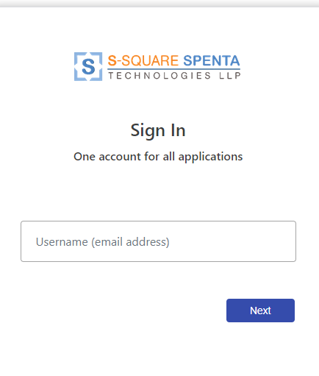

Figure 1 - Sign in Page / Log in Page

* Enter user id.
* Click on the next button.
* This will open the password page

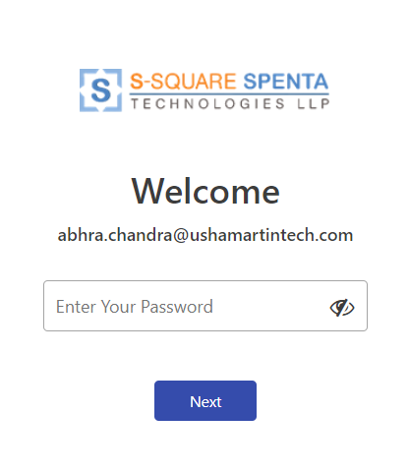

Figure 2 - Sig-In Password Entry Page

* Provide password to login.
* Click on next
* In case of successful authentication user will be redirected to the home page of the application.

## Home Page and General Features

After successful login user is redirected to the home page of the application which is Landlord View.

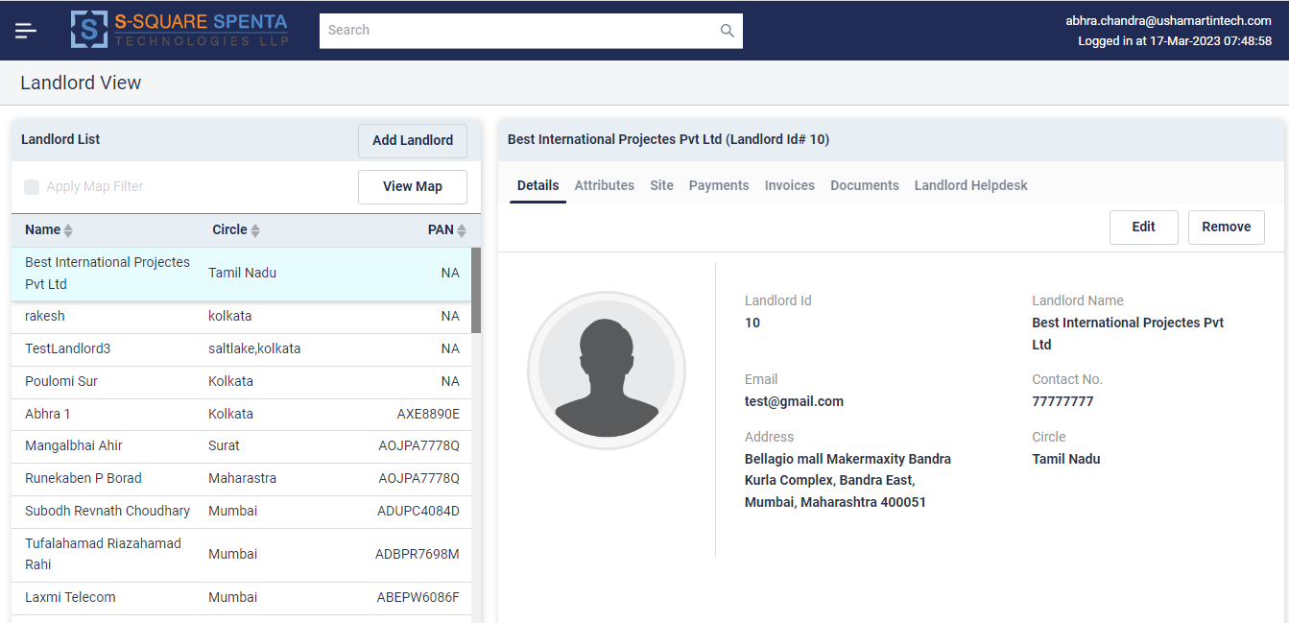

Figure 3 - Home Page after Signing In

General features are –

* Menu (Side Bar)
* Search (Header Bar)
* Logged in User Id and Login date time is shown in top right corner.

### Menu Bar

Menu bar can be accessed anytime by clicking on the following icon on the top left corner of the page.



Figure 4 - Hamburger Menu Icon

Menu bar provides navigation to following components or views.

* **Site** – Navigates to *Site View* for all site or property related operations
* **Landlord** - Navigates to *Landlord View* for all landlord related operations
* **Configurations** - Navigates to System Configuration View
* **User Management** - Navigates to user management view
* **Galaxy** – Navigates to Galaxy view
* **Invoice Management**- Navigates to Invoice Management view
* **My Tasks -** Here user can see the tasks assigned to him/her
* **Audit Trail** – Navigates to Audit Trail view
* **Report** – Navigates to Report view
* **Change Password –** Here user can change his/her password
* **Logout** – To sign out of the application

It is possible to seamlessly navigate from one view to another without any restrictions.

It is advised to save your work on the current view before navigating away from it, as the unsaved work (if any) will be lost on change of views.

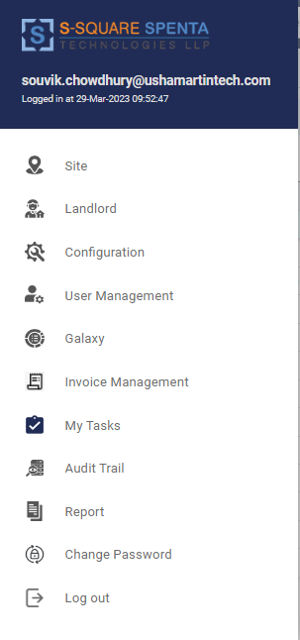

Figure 5 - Menu Bar (Expanded)

### Search Bar

Search Bar is present at the header part of the application.



Figure 6 - Search Bar

* User needs to enter the search string and then hit Enter button to search.
* The utility searches for the entities based on the currently selected view. For example if the currently selected view is Landlord, then the utility will search and retrieve the matching landlords and populate them in the Landlord List.
* In the same way, sites and assets can be searched from their respective views.
* Search option is NOT available in configurations view.

### How to Search

* There are two ways to search, generic (among all attributes) and specific (among specific attributes).
* To search for a landlord, site or asset generically, enter any search string in the search bar and hit Enter. All searches are case insensitive.
* The generic search utility searches for the entered string in the details field values and attribute values of the entities (Site / Landlord / Asset) and returns the entities having matching values.
* For example –
  + To Search with Landlord Name – enter the name of the landlord in the search bar and hit Enter.
  + To search for Landlords in a Circle – enter the circle name and hit Enter.
* The search string can be partial instead of exact. For example searching with *Amit* will return both landlords having attribute values Amit and Amitava.
* It is possible to search with multiple search strings together. Multiple search strings can be provided using comma as a separator. For Example –
  + To search landlords with name *Amit* and from the region of *Gurgaon* enter the search string as – *Amit,Gurgaon*.
  + To search all landlords with google email id and phone number having *9433* enter the search string as *gmail.com,9433.*

*Note: Generic search may return unintentional records, for example, Searching for landlords with name Amit may return a landlord whose name is not Amit but ‘Amit’ is mentioned in any other attribute value, may be Relationship manager of the Landlord. This is because generic search, searches all the attributes of the entity for any match.*

* Instead of generic search it is possible to search specifically for entities specifying the attribute name and value to search for. For example – to search for all landlords with region Gurgaon, enter the search string as – circle:Gurgaon in Landlord view. This will only list Landlords with Region name as Gurgaon and ignore any other field having the string Gurgaon.
* Specific search can also be done using multiple search string. For example – to search for all landlords with region Gurgaon and address on NH-10, enter the search string as – region:Gurgaon,address:nh-10
* It is also possible to combine generic and specific search together. For examples following is a valid search string – *Amit,Region:Gurgaon,Email:gmail.com*. This search string will search for all landlords having Amit in any attribute value and Gurgaon in region and gmail.com in Email attribute.
* Following are the supported keywords for the specific search per view–
  + Landlord View
    - ***LandlordName*** – To search in Landlord Names
    - ***ContactNo*** *–* To search in Landlord Contact Numbers
    - ***CIrcle****–* To search in Landlord Circles
    - ***Address*** *–* To search in Landlord Addresses
    - ***Email*** *–* To search in Landlord Email Addresses
  + Site View
    - ***SiteCode –*** To search in Site Codes
    - ***SiteName –*** To search in Site Names
    - ***Description –*** To search in Site Descriptions
    - ***Address -***  To search in Site Addresses
    - ***Circle***  - To search in Site Circles
    - ***Latitude -*** To search in Site Latitudes
    - ***Longitude***  - To search in Site Longitude
* Other than the keywords mentioned above, names of all Landlord, Site created dynamically (from configurations menu) can also be included in specific search condition.

### Logout

Click on the  menu in the side menu bar to Log out from the application.

# Configuration

Configuration View allows the user to configure the system as per the business requirements. In the configuration view user has access to a tabbed view of entities which can be configured. System allows configuring following entities –

* **Attributes –** Configure Site, Landlord, and Agreement attributes to capture.

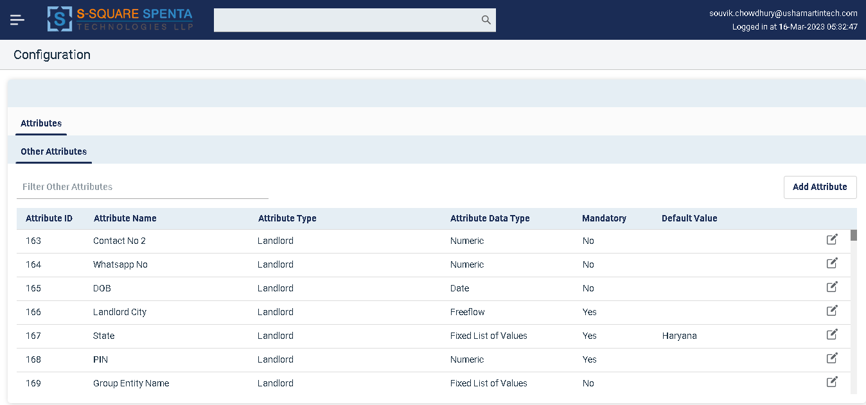

Figure 7 - Configuration View

## Attributes

* System allows configuring attributes dynamically to extend the application beyond the available fields to capture additional data as per business requirements.
* In Equipment Attributes sub tab - Attributes can be configured for equipment for each type of equipment.
* In Other Attributes sub tab - Attributes can be configured for sites and assets too. User may also configure property attributes which are associated with sites. *Typically technical attributes of a site are defined as Site attributes and physical attributes are configured as property attribute.*

### Other Attributes

* Other Attributes refer to Site, Property and Landlord attributes.
* To view Other Attributes details, click on “**Other Attributes**” sub tab under the “**Attributes”** tab of configuration.

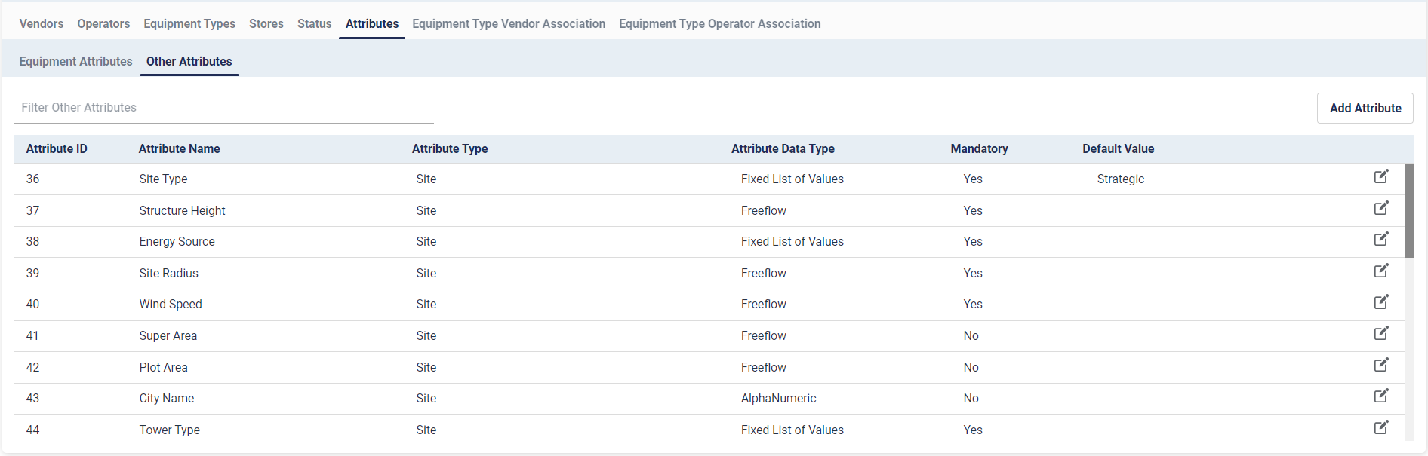

Figure 8- Other Attributes

* To filter the Other Attributes list –
  + Enter any text in the filter bar. System will match the entered text with all the fields (Attribute ID, Attribute Name, Attribute Type, Attribute Data Type, Mandatory, and Default Value) of the Attributes list and filtered out the once not matching.
* To edit any details of Equipment Attributes
  + Click on  icon.
  + This will open the Edit dialog

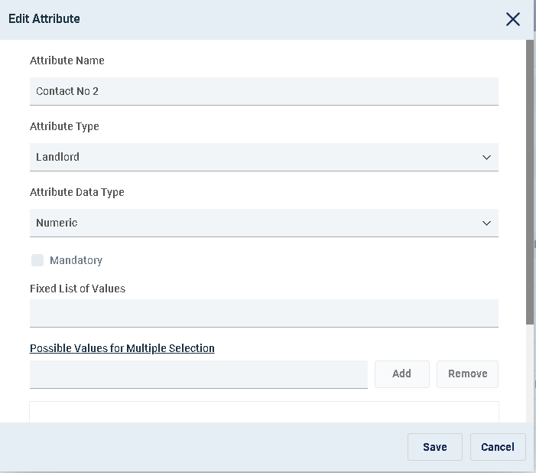

Figure 9 - Edit Attribute Dialog

* + Note that only Default value and Fixed List of Values (for Attribute with data type Fixed List of Values) can be modified and saved.
* To add Other Attributes
  + Click on  button.
  + Enter “Attribute Name”
  + Select Attribute Type – any one of *Site*, *Landlord* or *Property*
  + Select “Attribute Data Type”. The allowed data types are –
  + *Numeric* – If an attribute data type is selected as numeric then only digits can be entered in the attribute value including decimal numbers. For example *123*
  + *Alpha Numeric* – If an attribute data type is selected as alpha numeric then only characters (A-Z and a-z) and digits can be entered in the attribute value. For example *Ab120*
  + *Freeflow -* If an attribute data type is selected as freeflow then all characters including special characters and digits can be entered in the attribute value. For example *A@#$%b(120098}*
  + *Date –* If an attribute data type is selected as date then calendar appears for date selection.
  + *Boolean -* If an attribute data type is selected as Boolean, the user will have two options to select from i.e. ‘True’, ‘False’.
  + *Multiple Selection -* If an attribute data type is selected as Multiple Selection, the user will have option to add or remove Possible values for Muliple Selection.
  + *Image File -* If an attribute data type is selected as Image File, user will have option to upload an image file as value.
  + *Text File -* If an attribute data type is selected as Text File, user will have option to upload a text file as value.
  + *Custom File – If an attribute data type is selected as Custom File, user will have option to upload custom file types as value.*
  + *Fixed List of Values –* For attributes of data type Fixed List of Values (FLOV) additionally Fixed List of Values field need to be entered. Enter all the allowed values comma separated. For example *Yes, No.* For this type of attributes the field will be a drop down with the values populated as options. For this example *Yes* and *No* will be available for selection in the drop down.
* Check the mandatory check box  if you want the attribute to be mandatory otherwise not.
* Select “Possible Values for Multiple Selection”. You can either add new values by clicking the “add” button  or remove values by clicking “remove” button .
* Enter a value in the **Default Value** field if you want to auto populate any attribute
* Save it by clicking on  button.

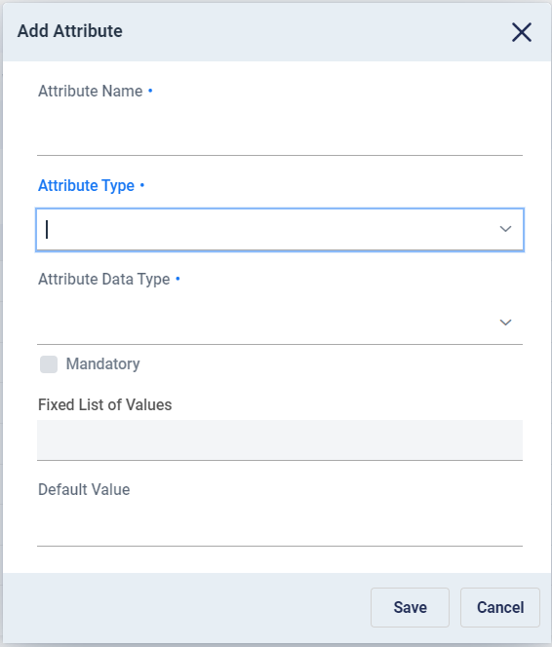

Figure 10 - Add Other Attribute Dialog

# Site

Sites are physical location of properties leased by TowerCo for building tower infrastructure. From the Site View, users can add, view and manage operations of sites in the system.

* To go to the Site View
  + Click on ** option in the menu bar

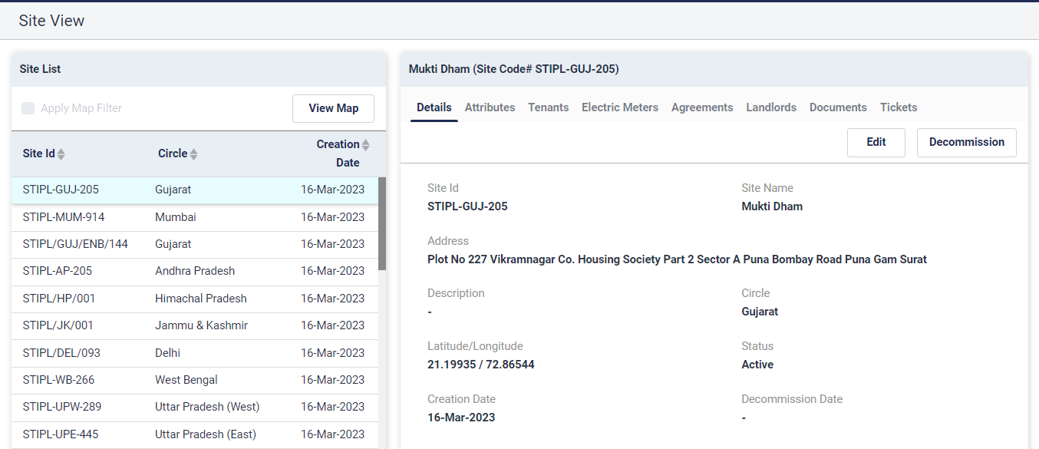

Figure 11 - Site View

## Site View

* There are two sections of the site view user interface.
  + **Site List** – The left section of the interface lists sites in the system.

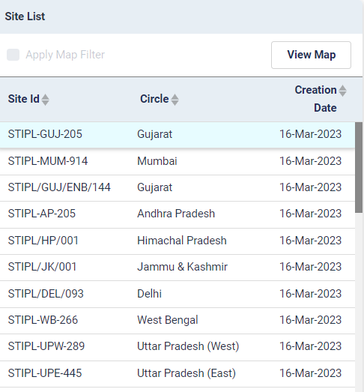

Figure 12 - Site List

**Site Id, Circle** and **Creation Date** are shown in the list. User may click on one record to select it.

By default latest 50 (configurable) sites, based on their RFAI date are retrieved and displayed in the list.

To sort the site list based on a field click on the  icon beside that field. Clicking on upper arrow will sort in descending order, whereas clicking on the lower arrow will sort in ascending order.

* + **Site Details** – The right section of the interface shows the details of the selected site in grouping the information logically in tabbed interface.

The top header shows the site name and site code for which the details are being shown.

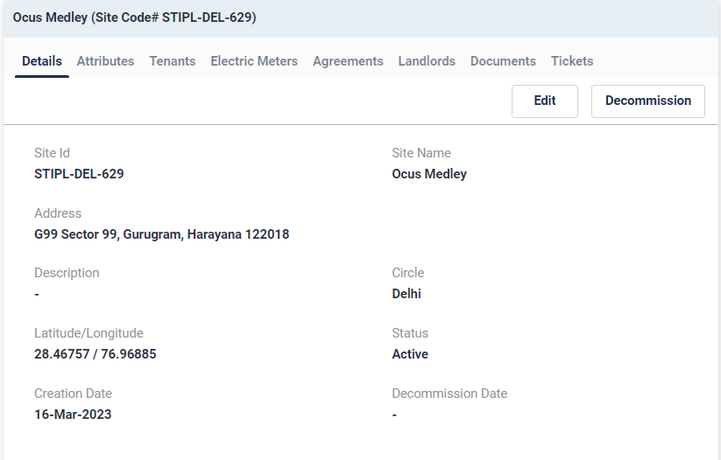

Figure 13 - Site Details

## Map View of Sites

* In the “**Site List”** section of the “**Site View**”, there is a “**View Map**” option. It shows the sites retrieved, plotted on a Google map.

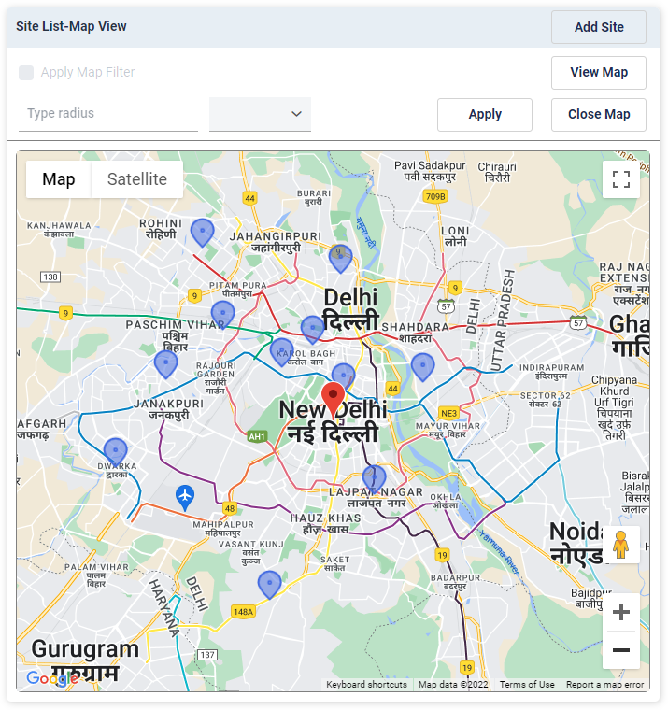

* To open the map view click on the  button.
* All the sites from the site list will be shown with blue marker 
* The center of the map is shown with a red marker . The center of the map can be dragged around to make another point t be center of the map.
* User may click on the blue site markers to view the address on the map. This will also retrieve the details of the Site in the Site Details section on the right.

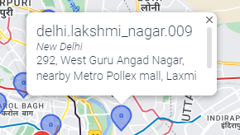

* Additionally user may apply map filter to identify sites within a certain radius around the center of the map.
* To apply map filter –
  + Check the check box.
  + Enter desired radius value in Type Radius field .
  + Select the desired unit (meters, kilo meters and miles) 
  + Click on the  button to apply the radius filter
  + It will draw a light blue circle on the map. The red marker being the center. The sites which fall outside the circle are marked with grey markers. 
  + 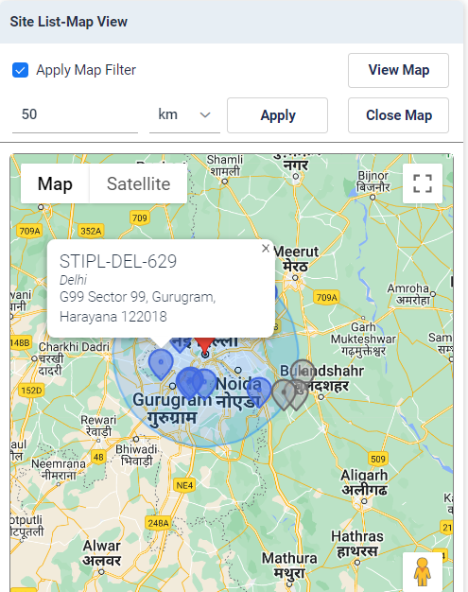

Figure 14 - Map View with Map Filter Applied

* + To exit out of the map view and go to the site list view click on the  button.

## Edit Site Details

To edit a site a details –

* Select the site from the Site List
* Go to the **Details** tab in the Site Details view
* Click on the  button
* It will open the Edit dialog
* User may modify Site Name, Address, Coordinates (lat/long) and Region
* Click on the  button to save.

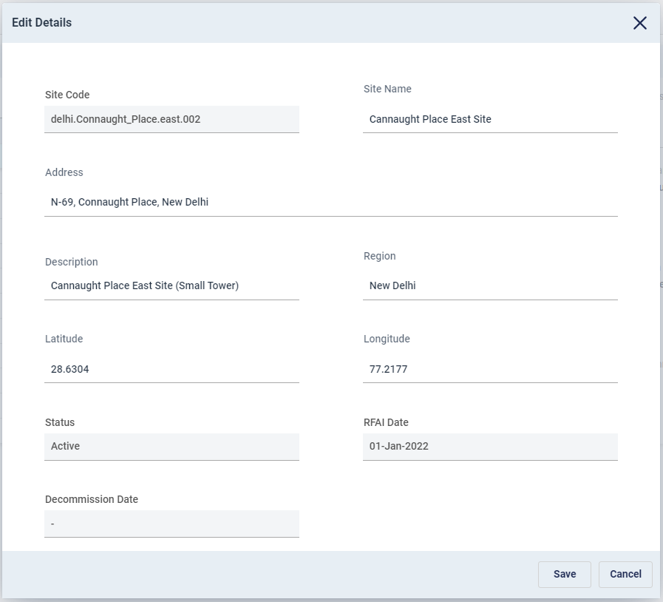

## Decommission Site

Once a site is physically dismantled it can be marked as decommissioned.

* To mark a site as decommissioned –
  + Select the site from the Site List
  + Go to the **Details** tab in the Site Details view
  + Click on the button
  + A confirmation message box will appear and user needs to confirm the choice.

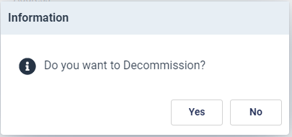

* + If confirmed, the user needs to enter the decommission date and then click on the  button.

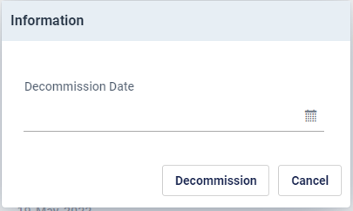

* + Once a site is decommissioned, landlords associated with the site is also removed
  + Once a site is decommissioned following operations can NOT be performed on it
    - Edit Details
    - Edit Attributes
    - Decommission
    - Add or Edit Agreement
    - Add or Edit Landlords
    - Add or Edit Active Assets
    - Add or Edit Passive Assets
  + It is advised to remove any active or passive assets from the site before decommissioning it.
  + Documents can be uploaded and Tickets can be raised on decommissioned sites.

## View Site Details

Select one site from the Site list of the Site View to retrieve and view the details of that Site in the site details section on the right. System provides following group of information for each site.

* **Details**
* **Attributes**
* **Tenants**
* **Electric Meters**
* **Agreements**
* **Landlords**
* **Documents**
* **Tickets**

### Details

* To see the details of a site, click on the “**Details**” tab .
* Site Code, Site Name, Address, Description, Region, Coordinates (Lat/Long), Status, RFAI Date, Decommission Date are shown.
* Status can be active or pending or decommissioned

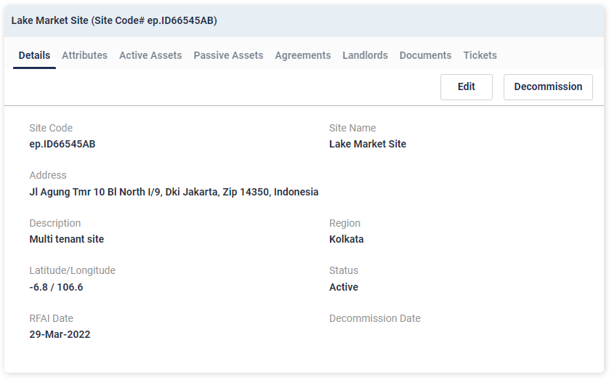

Figure 15 - Site Details

### Attributes

* Site and Properties attributes (as per definition in configuration “Other Attributes”) are shown here.
* The attributes are dynamically populated as defined in the configuration.

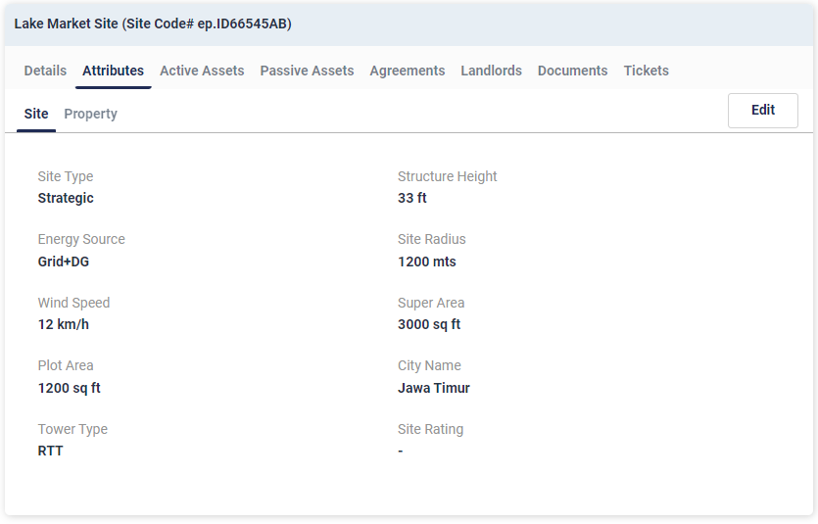

Figure 16 - Site Attributes

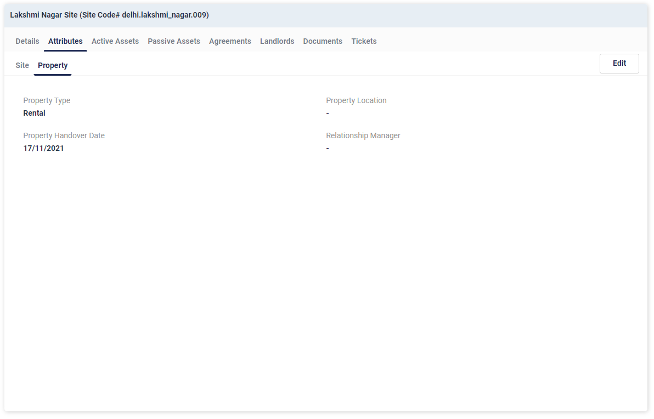

Figure 17 - Property Attributes

* To Edit the attributes –
  + Click on the button.
  + This will open the Edit dialog
  + Enter or modify the attributes as required and then save.

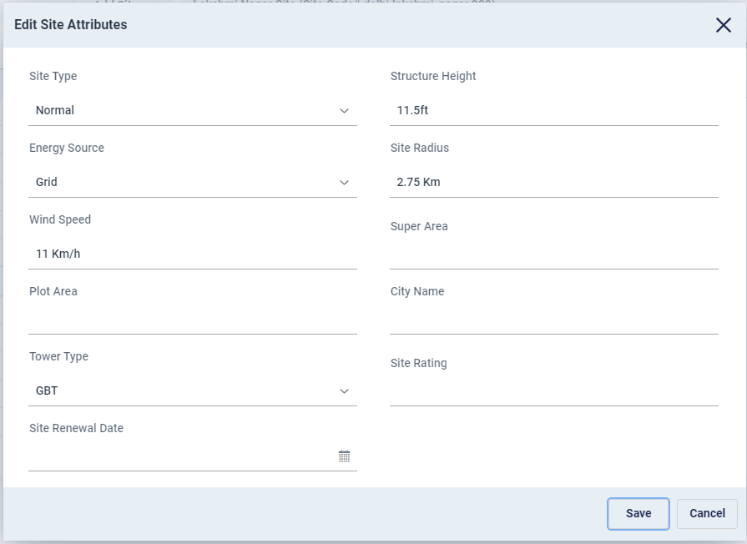

Figure 18 - Edit Attributes Dialog

### Tenants

* Click on the “Tenants” tab to view all the OpCo tenants of that particular Site.
* Following Details for the Tenants are shown
  + Event Code
  + Opco Name
  + Solution Type
  + Project Reference No.
  + MRFAI Date
  + Status
  + Removal Date
  + Remarks
  + Project Status

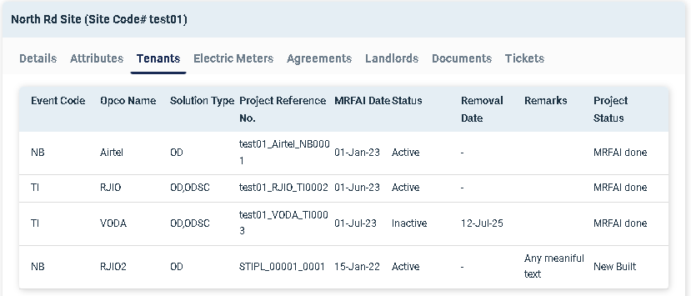

Figure 19 - Site Tenants

Tenant details are obtained from Tarantula via integration. This information is readonly.

### Electric Meters

* Click on the “Electric Meters” tab to view Electric Meters for that particular Site. There can be multiple electric meters in a site.
* Following details for the “Electric Meters” will be shown
  + Meter ID
  + Creation date
  + Meter Category
  + Serial No.
  + SEB Meter Installation Date
  + SEB Meter Authority
  + Status
  + Consumer No.

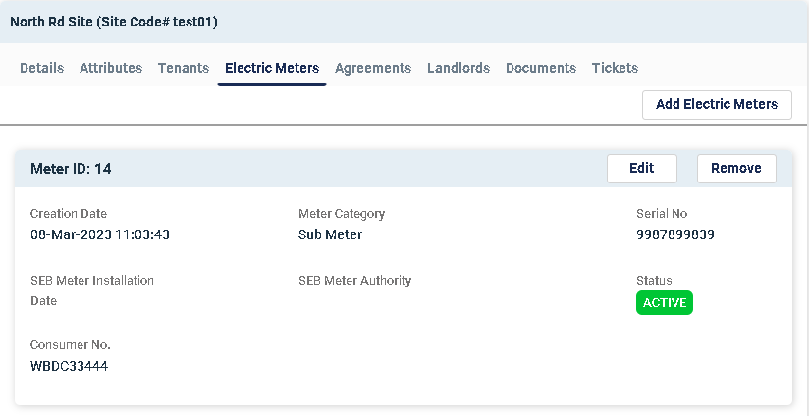

Figure 20 - Site electric meters

* New meters can be added to a site by clicking the  button.

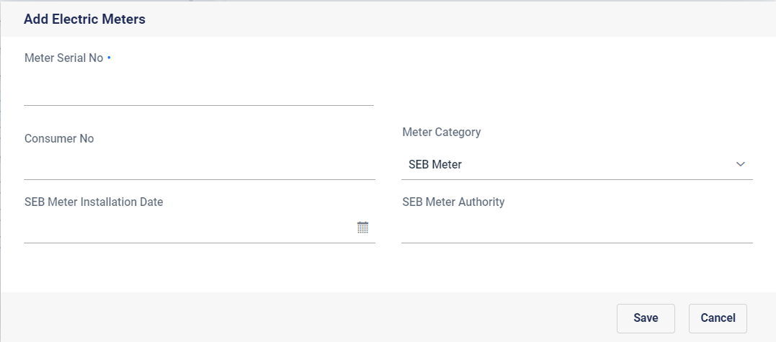

Figure 21 - Add meter dialog

* User may enter following details and save
  + Meter serial number,
  + Consumer number
  + Meter Category
  + SEB Meter Installation Date
  + SEB Meter Authority
* By clicking the “Edit” button user can edit the following details of a particular Electric Meter
  + Consumer No.
  + Meter Category
  + SEB Meter Installation Date
  + SEB Meter Authority

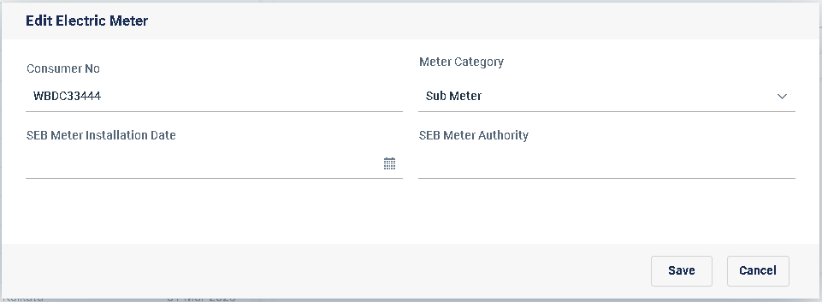

Figure 22 - Edit meter

* Once updated, user can save the edits by clicking the “Save” button  or user can revert back by clicking the “Cancel” button.
* By clicking the “Remove” button  user can remove the particular Electric Meter

### 6.6.5. Agreements

* Lease or Rent Agreement can be stored at site level for the property. There can be multiple agreements per site for different years. If there are multiple agreements in the site, the dates for the agreements should be exclusive of each other.
* Click “**Agreement**” tab to view, all agreements (past and current) in the site.

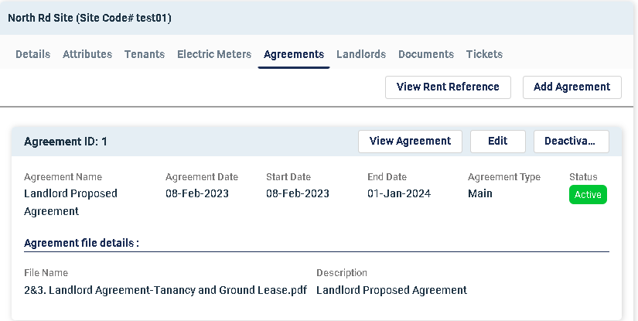

Figure 23 - Site Agreements

* If a document was uploaded during creation of the agreement then the View Agreement button is enabled, otherwise it remains disabled.
* To view the agreement document click on the  button. This will download the agreement document..
* To edit an agreement user need to click on the Edit button of that agreement.
* This will open the Edit dialog with two tabs naming “Basic” and “Details”. User may change the agreement name and upload the document. The current document will replace the existing document.
* Agreements dates can not be modified once created

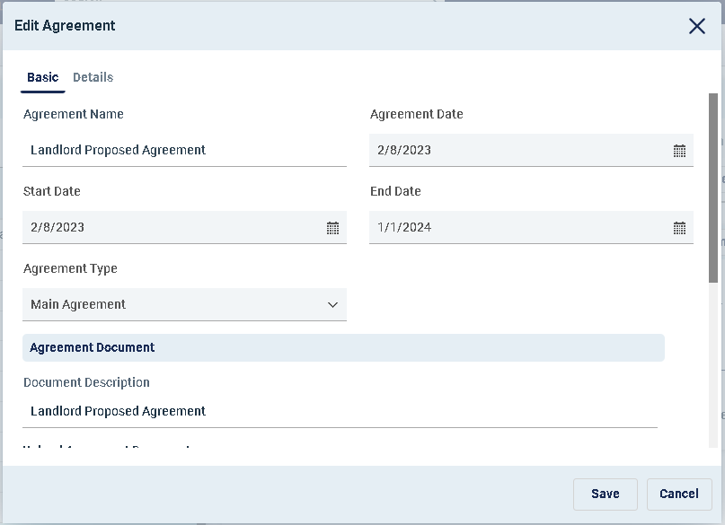

Figure 24 - Edit Agreement Dialog-Basic

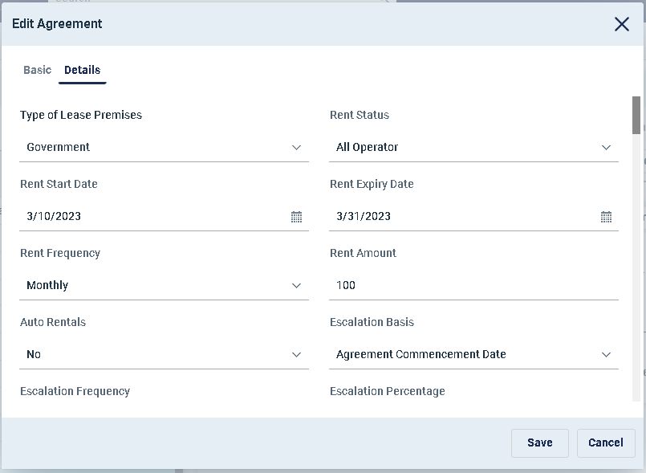

Figure 25 - Edit Agreement Dialog-Details

* To add a new agreement –
  + Click on the button
* This will open the Add Agreement Dialog with two tabs naming “Basic” and “Details”. The “Details” tab will only be accessible after creating an agreement.

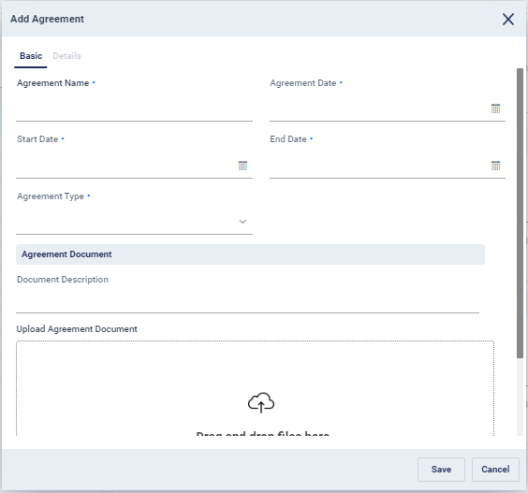

Figure 26 - Add Agreement Dialog-Basic

* + Enter “**Agreement Name**”, “**Agreement Date**”, “**Start Date**”, “**End Date**”,

**“Agreement Type”**, “**Document Description**”, and upload “**Agreement Document**”.

* + Agreement Start and End Date should be exclusive of any already existing agreement on that site.
  + To save click on button.
  + Once an agreement is created it remains in Pending state. An approval workflow named “First Document Approval” is automatically launched.
  + Once the workflow is approved by all the approvers, the agreement becomes active.
  + For workflow execution, see Section 13. My Task.

### Landlords

Landlords are the owners of the property on which the sites are built and maintained. Hence landlords are associated with the Sites. There can be multiple landlords for a site.

* Click “**Landlords** ” tab to view, all landlords associated with the Site
* For each landlord **Landlord Name, Email, Contact No, Address, Pay-out Share** and **Status** is shown. Only the active landlords are shown.

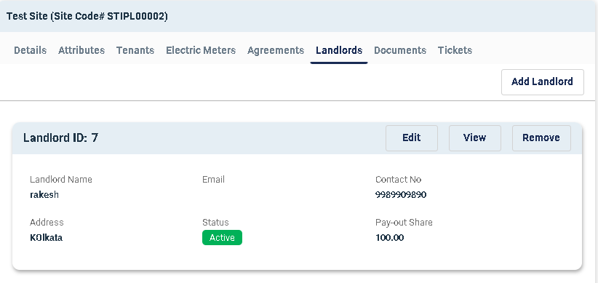

Figure 27 - Landlords at Site

* Users may view the landlord details by clicking  button. This will open the landlord view with the selected landlord retrieved in a new tab.
* The landlord payment amount can be edited for a particular landlord details from the list
  + click on  button
  + This will open the edit dialog

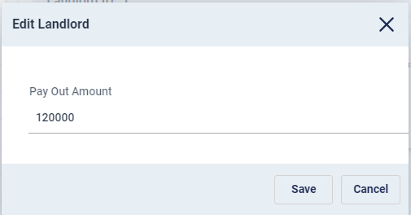

Figure 28 - Edit Landlord Pay out Amount

* + User may modify the payout amount and save.
* To remove particular landlord from Site, click on the  button. User needs to confirm the choice. This will remove the landlords from site
* To add a landlord to a Site –
* Click on the button.
* This will open the Add landlord Dialog

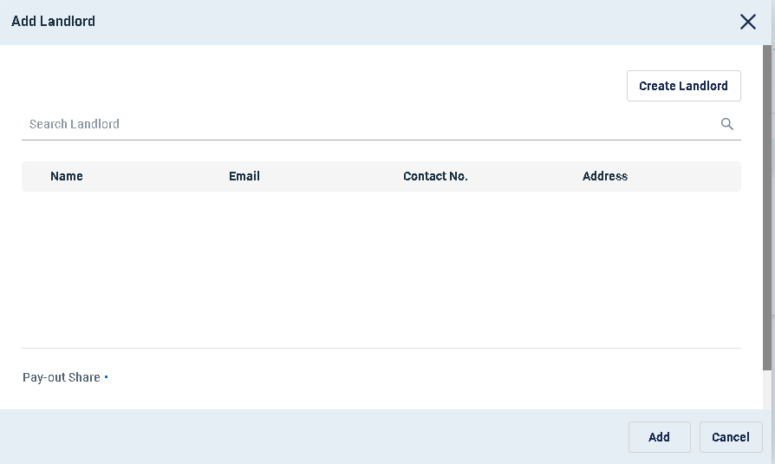

Figure 29 - Add Landlord Dialog

* User may search the landlord by name or email or id. User need to enter the search string in the search landlord bar and hit Enter.
* This will retrieve a list of landlords matching with the search criteria**.**
* Entering nothing in the search bar and hitting Enter will retrieve most recent 50 (at most) landlords and list.
* Only the active landlords are shown**.**

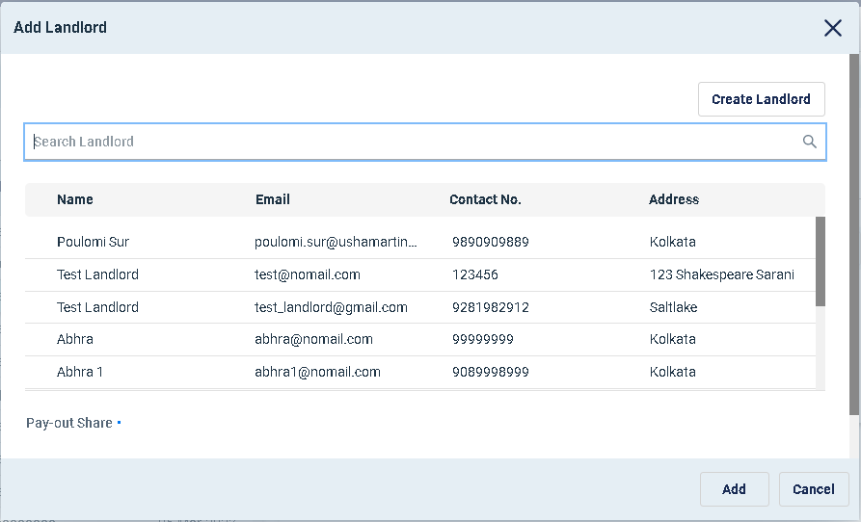

Figure 30 - Add Landlord Dialog with Landlords

* User need to select one landlord from the list and enter the pay-out amount and click on Add to add the landlord.
* Same landlord can not be added twice in active state in the same site.
* If a landlord was earlier added to a site and then removed, then it can be again added to the same siteTo add a landlord to the site, the landlord must be created beforehand or you can create a Landlord by clicking the “Create landlord” button  at the “Add Landlord” screen. It will open up the Add Landlord section of the Landlord view.(Please refer to the Landlord View -> Add Landlord section of the document)

### Documents

The application provides an option to upload, view and download documents at site level. Documents can be any document related to the site, for example site engineering drawing or electrical layout or site maintenance plan etc. There is no restriction on number of documents being added to the site.

* To view and manage the site documents
* Click “**Document**” tab to view all the documents in list view.
* For each document “**Document Type**”, “**Name**” and “**Description**” is shown.
* To view a content of the document click on the icon beside the document. This will open the document content in a new tab.
* To remove a document, click on the  icon. User needs to confirm the choice of deletion. This will physically delete the document from the application storage.

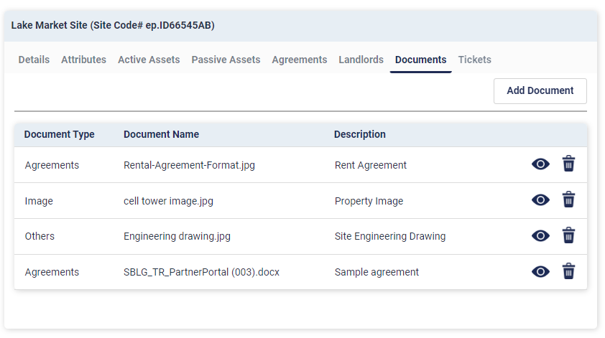

Figure 31 - Site Documents

* To add documents, click on button.
* This will open the add document dialog

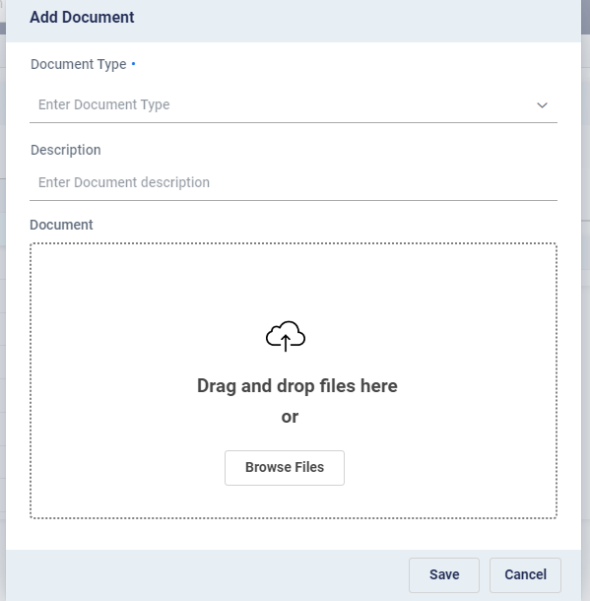

Figure 32 - Add Document Dialog

* Select “**Document Type**” from the drop down menu. The options are –
  + *Plan –* Technical plan documents related to site, i.e. Structural Load Plan, Engineering Drawing Plan, and Electrical Layout Plan etc.
  + *Address –* Proof of address kind of documents
  + *Image –* Images of the entity or of things related to the entity
  + *Agreements –* Agreements type of documents. Lease or Rent or Service agreements.
  + *Others –* Any other document category
* Enter a short description about the document.
* Click on the browse files to open the File dialog to choose the file from local system or drag and drop the file in the designated area.
* And upload the respective document.
* Click on the save button to upload the documents

Note: *During site level agreement creation the agreement document uploaded is also shown under the site documents. It refers to the same copy of the document. Deleting that document from here will remove the document from the Agreements too.*

### Tickets

Trouble Tickets can be raised as part of corrective or preventive maintenance activities of sites. It is called reporting an incident. The application allows to raise and view and track incidents.

* To view and manage the incidents click on “**Tickets**” tab
* It shows the list of open or closed tickets or incidents raised against this site
* Following fields of the incident are shown in the list view –
  + **Docket#** - Identifier for the incident or ticket.
  + **Incident Name** – Name or type of the incident
  + **Status** – Status of the incident. Open or Closed

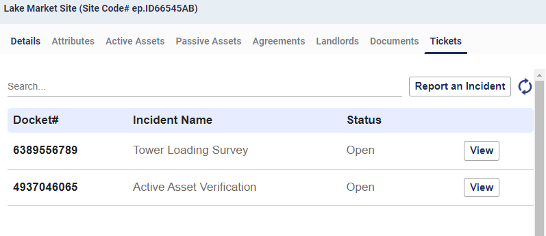

Figure 33 - Site Tickets or Incidents

* To filter the incident list –
  + Enter any text in the search bar. System will match the entered text with all the fields (Docket#, Name, Status) of the vendor list and filtered out the ones not matching.
* To refresh the incident list user may click on the  icon
* To view details of a ticket click on  button beside that ticket or incident.
* It will open the ticket / incident details dialog

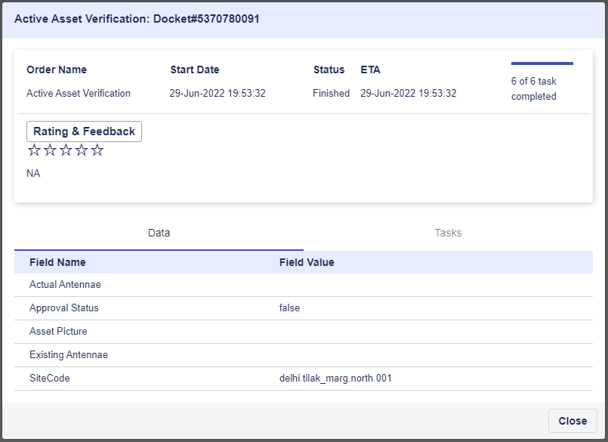

Figure 34 - Ticket Details Dialog

* It shows the following information –
  + Order Name – Name of the Incident
  + Start Date – Date on which the ticket was raised
  + Status – State of the ticket. Either Open or Finished
  + ETA – Expected completion time.
  + Progress bar – Shows number of tasks completed out of total number of tasks in the ticket
  + In the lower section there are two tabs naming Data and Tasks.
  + In the Data tab it show data of the instance which were supplied during ticket creation or task execution. The data fields are dynamic and change from ticket type to ticket type as per template configuration
    - In the Tasks tab the task details of the ticket is shown with the following details- Task Name
    - Task Type – Either Manual or Automatic
    - Task State
      * To Start – Task is assigned but the engineer or technician or user has not accepted it yet
      * Started – Task is accepted by the engineer or technician or user
      * Finished – Task is closed by the engineer or technician or user
    - Assigned To - The engineer or technician or user, the task is assigned to.

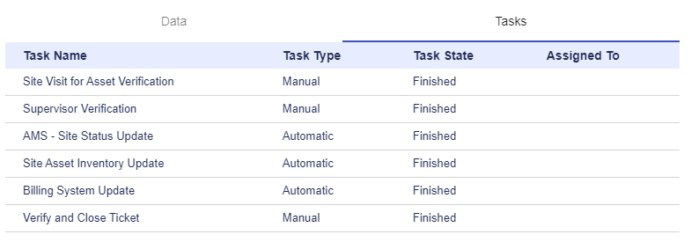

Figure 35 - View of Tasks in a ticket

Note: *This view of the ticket is read only, as in it can not be modified by the user. As and when the tasks are worked upon by the engineer or technician or user the view of the ticket gets changed accordingly.*

* There is an option to provide rating and feedback on the closed tickets.
  + Click on the button.
  + This will open the Rating & Feedback window.

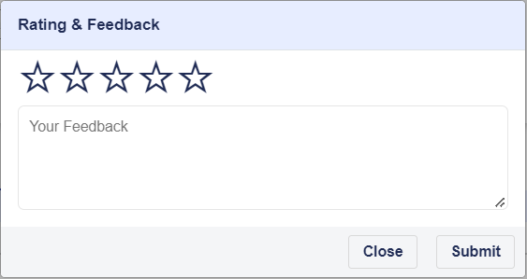

Figure 36 - Ticket Rating & Review Dialog

* + Click on the stars to provide rating.
  + Enter feedback
  + Click on  button to save the rating and review.
  + This will show the rating and feedback on ticket details page.

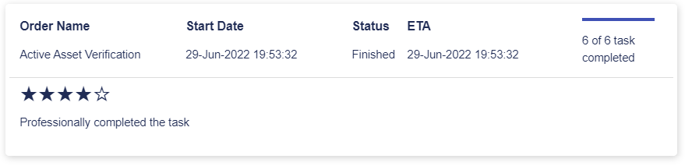

Figure 37 - Ticket Rating & Review

Note: *Rating & review can be provided only on closed ticket and only once. If rating and review is already given for a closed ticket it can not be given again.*

* To report a new Incident or raise a new ticket –
  + Click on the button.
  + This will open the Report Incident dialog
  + Select the Incident Type to raise from the drop down.
  + The list can be filtered by typing the search text in the search bar
  + Based on the selected incident type, launch parameters are loaded dynamically.
  + Enter values in the launch parameters as appropriate.
  + Some of the launch parameters may have value already populated and disabled. Ignore them.
  + Click on the save button to create the incident.

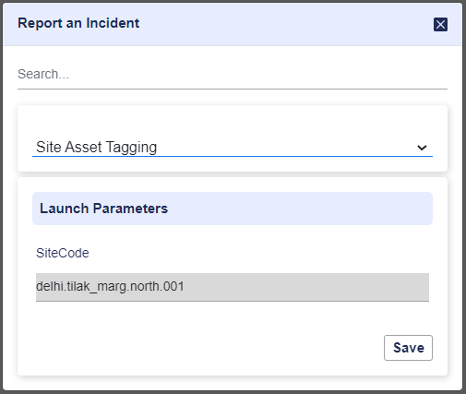

Figure 38 - Report an Incident Dialog

* + Once the incident is successfully created a message appears with the docket number.

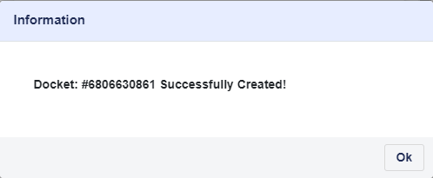

Figure 39 - Incident Creation Message

* + The docket also appears in the ticket list with Open status
  + System allows raising same types of ticket multiple times for the same site

# Landlord

Landlords are owner of the physical property locations leased by the TowerCos. TowerCos have agreements with landlords for their property usage.

To go to the Landlord View

* + Click on  menu in the side menu bar

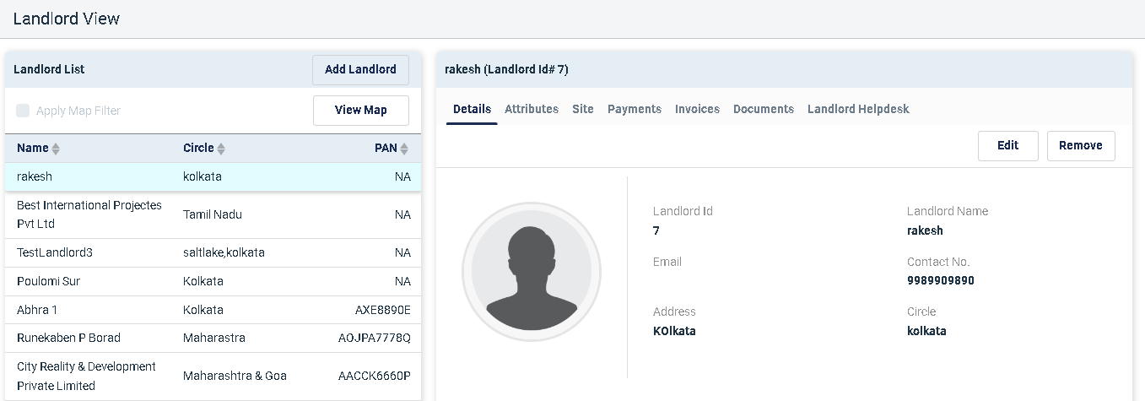

Figure 40 - Landlord View

## Landlord View

* There are two sections of the landlord view user interface.
  + **Landlord List** – The left section of the interface lists landlords in the system.

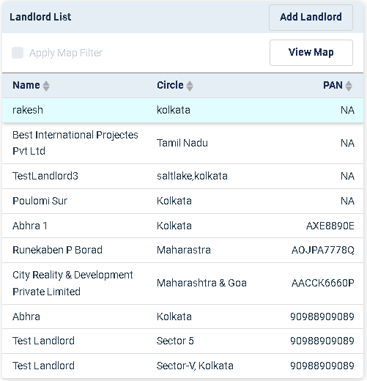

Figure 41 - Asset List

**Name, Circle** and **PAN** are shown in the list. User may click on one record to select it.

By default latest 50 (configurable) landlords, based on their creation date are retrieved and displayed in the list.

To sort the landlord list based on a field click on the  icon beside that field. Clicking on upper arrow will sort in descending order, whereas clicking on the lower arrow will sort in ascending order.

* + **Landlord Details** – The right section of the interface shows the details of the selected landlord in grouping the information logically in tabbed interface.

The top header shows the landlord name and landlord unique id for which the details are being shown.

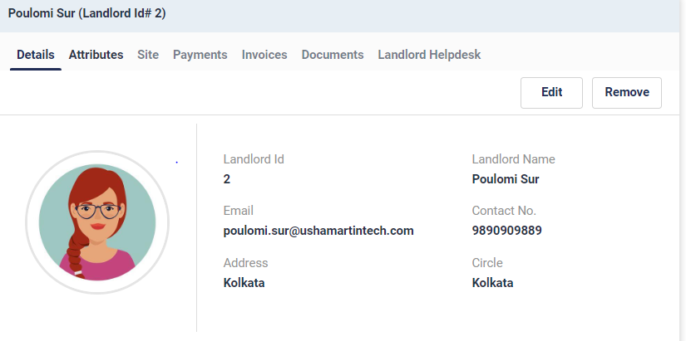

Figure 42 - Landlord Details

## Map View of Landlords

* In the “**Landlord List”** section of the “**Landlord View**”, there is a “**View Map**” option. It shows the landlords retrieved, plotted on a Google map based on the coordinates of the sites they are associated with.

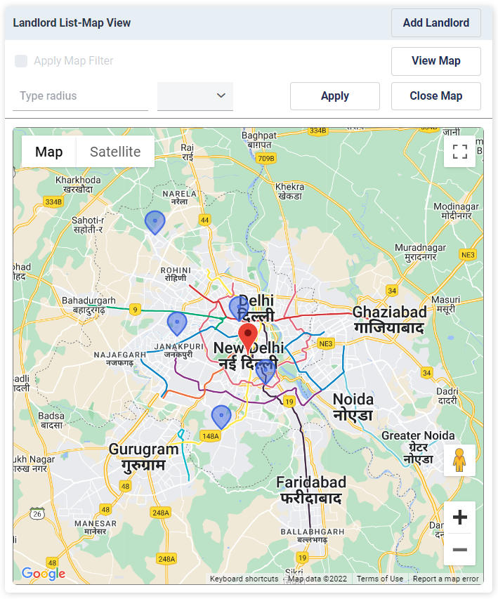

Figure 43 - Landlord Map View

* To open the map view click on the  button.
* Landlords will be shown with blue marker . Landlords who are only associated with sites are shown in the map. Landlords who are not associated with any site are not shown on the map.
* The center of the map is shown with a red marker. The center of the map can be dragged around to make another point to be the center of the map.
* User may click on the blue asset markers to view the landlords. This will also retrieve the details of the Landlord in the Landlord Details section on the right.

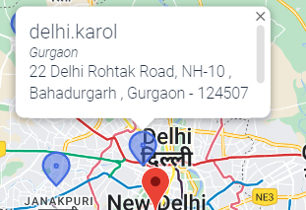

* Additionally user may apply map filter to identify assets within a certain radius around the center of the map.
* To apply map filter –
  + Check the check box.
  + Enter desired radius value in Type Radius field.
  + Select the desired unit (meters, kilo meters and miles) 
  + Click on the  button to apply the radius filter
  + It will draw a light blue circle on the map. The red marker being the center. The assets which fall outside the circle are marked with grey markers. 

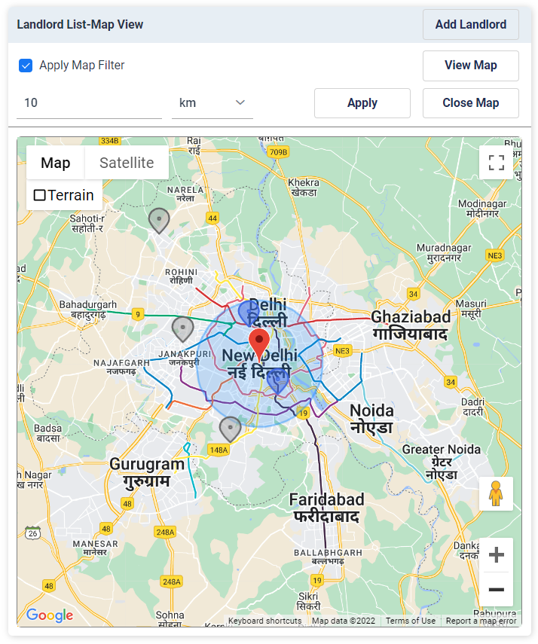

Figure 44 - Map View with Map Filter Applied

* + To exit out of the map view and go to the site list view click on the  button.

## Add a New Landlord

* To add a new Landlord –
  + Click on  button from the Landlord List of the Landlord view
  + This will open the Add Landlord dialog

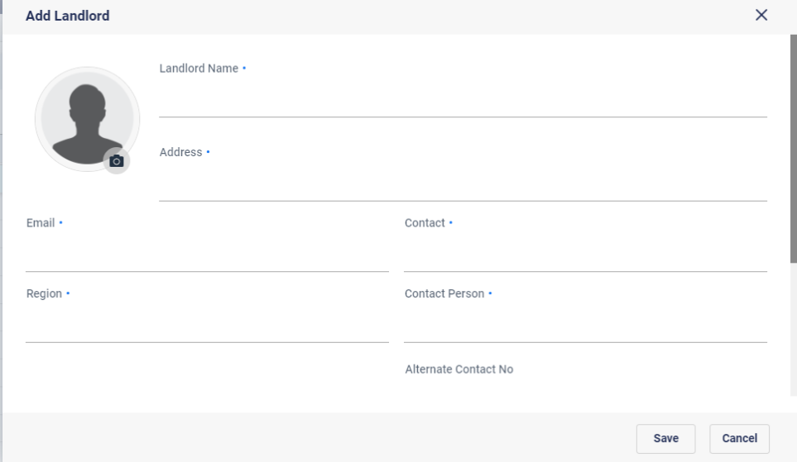

Figure 45 - Add Landlord Dialog

* + Enter the details as applicable. Either Email or Contact no. is mandatory.
  + To upload a file click on the “Upload” button .
  + To upload an image of the landlord, click on the icon.
    - This will open the photo upload dialog
    - Click on button to open the File Open dialog and select the image file.
    - Otherwise drag and drop the image file.
    - Click on Save

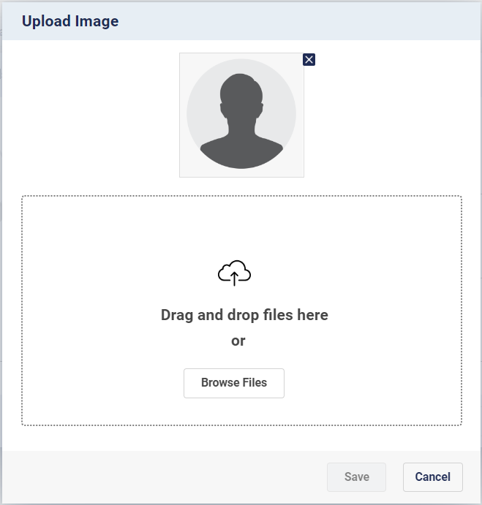

Figure 46 - Landlord Photo Upload Dialog

* Based on the configuration, additional attributes will be dynamically populated in the screen. Enter appropriate values for Landlord level attributes.
* Click on “**Save**” button to create the new landlord with the provided details
* Once the landlord is created successfully the same is retrieved and shown in the Landlord List

Note: *When a new landlord is created successfully, credentials for Landlord Self Service portal is generated and sent via an email to the landlord email id.*

## Edit Landlord Details

To edit a landlord details –

* Select the landlord from the Landlord List
* Go to the **Details** tab in the Landlord Details view
* Click on the  button
* It will open the Edit dialog

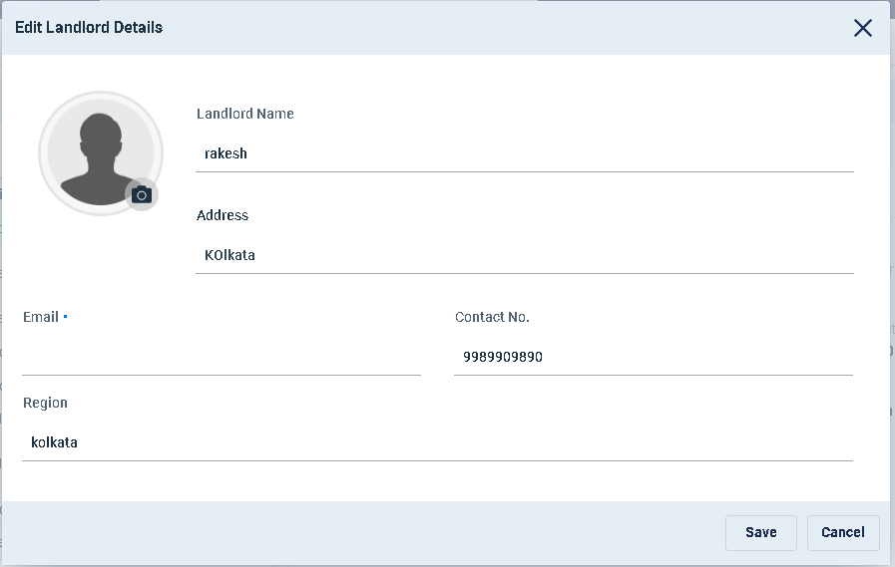

Figure 47 - Edit Landlord Details

* User may modify Landlord Name, Address, Email, Contact No. and Region
* To change the image of the landlord, click on the icon
  + - This will open the photo upload dialog
    - Click on button to open the File Open dialog and select the image file
    - Otherwise drag and drop the image file
    - Click on Save in the photo upload dialog to close it
* To remove the image of the landlord, click on the icon
  + - This will open the photo upload dialog
    - Click on the on the top right corner of the current photo. That will remove the photo.
    - Click on Save in the photo upload dialog to close it.
* Click on the  button to save the changes for the landlord

## Remove a Landlord

To remove a landlord from the Landlord Management System–

* Select the landlord from the Landlord List
* Go to the **Details** tab in the Landlord Details view
* Click on the button
* System will ask for confirmation
* Once confirmed the landlord will be removed from the system. The Landlord Self Service credentials will also be removed for the landlord. Hence the landlord will not be able to access Landlord Self Service portal

Note: *If a landlord is associated with a Site, then that landlord can not be removed. In that case, the landlord first needs to be removed from site (Refer* *here**) and then removed from the Landlord Management System.*

## View Landlord Details

Select one landlord from the Landlord list of the Landlord View to retrieve and view the details of that Landlord in the landlord details section on the right. System provides following group of information for each landlord.

* **Details**
* **Attributes**
* **Site**
* **Payments**
* **Invoices**
* **Documents**
* **Landlord Helpdesk**

### Details

* To see the details of a landlord, click on the “**Details**” tab.
* **Landlord Id** (Unique Number), **Landlord Name**, **Email**, **Contact No.**, **Address** and **Circle** are shown

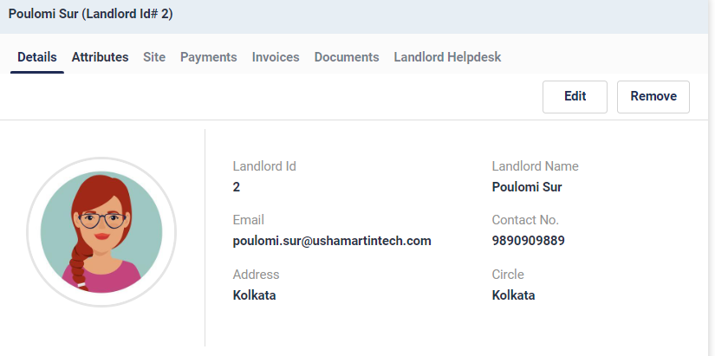

Figure 48 - Landlord Details

### Attributes

* Landlord attributes (as per definition in configuration “Other Attributes” with Attribute Type “Landlord”) are shown here.
* The attributes are dynamically populated as defined in the configuration.

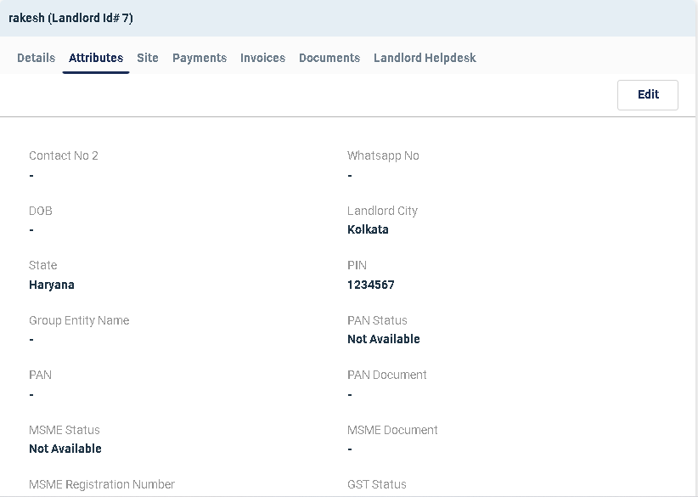

Figure 49 - Landlord Attributes

* To Edit the attributes –
  + Click on the button.
  + This will open the Edit dialog
  + Enter or modify the attributes as required and then save.

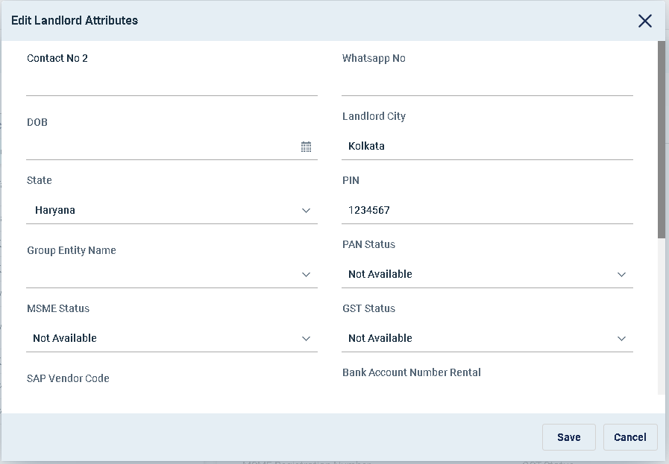

Figure 50 - Edit Attributes Dialog

### Site

The sites associated with the landlord are shown here. There can be multiple sites for a landlord.

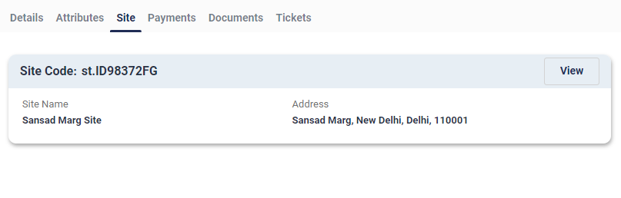

Figure 51 - Landlord Sites

*Site Code*, *Site Name* and *Address* are shown as quick information.

To view the details of the site, click on the  button. That will open the site details in site view in a new tab.

### Payments

Click “**Payments**” tab to view all the payments made to the landlord for different sites

* Payments are site specific

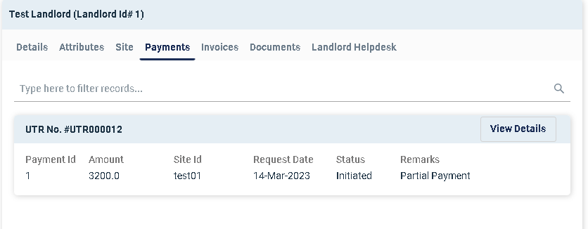

Figure 52 - Landlord Payments

* Header section of the payment shows the Transaction Id
* Payment Id (System Generated Unique Identifier), Amount, Site Id, Request Date, Status, Remarks are shown
* To view detailed breakup of the payment user needs to click on the  button

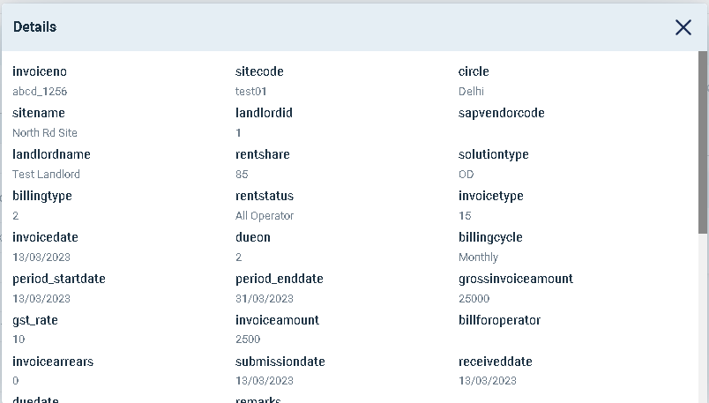

Figure 53 - Payment Details

* If no breakup details are available the  button may not be available or disabled

### Invoices

Click the “Invoices” tab to view the invoices associated with the particular Landlord. The invoices are shown in a tabular format. Key details of the invoices for the landlord are shown.

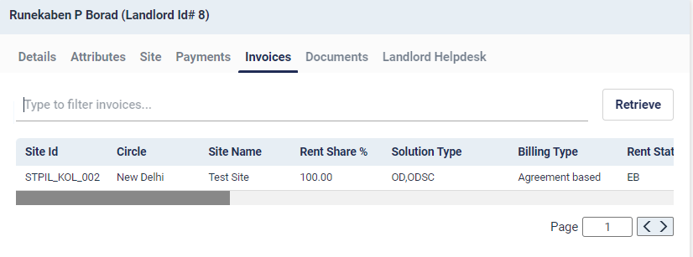

Figure 54 - Landlord Invoices

To filter the invoice records, Type relevant search text in the ‘Type to filter invoices’ area and click the  button.

### Documents

The application provides an option to upload, view and download documents at landlord level. Documents can be any document related to the landlord, for example identity card or address proof or agreements etc. There is no restriction on number of documents being added to the landlord.

* To view and manage the landlord documents
* Click “**Document**” tab to view all the documents in list view.
* For each document “**Document Type**”, “**Document Name**” and “**Description**” are shown.
* To view a content of the document click on the icon beside the document. This will open the document content in a new tab.
* To remove a document, click on the  icon. User needs to confirm the choice of deletion. This will physically delete the document from the application storage.

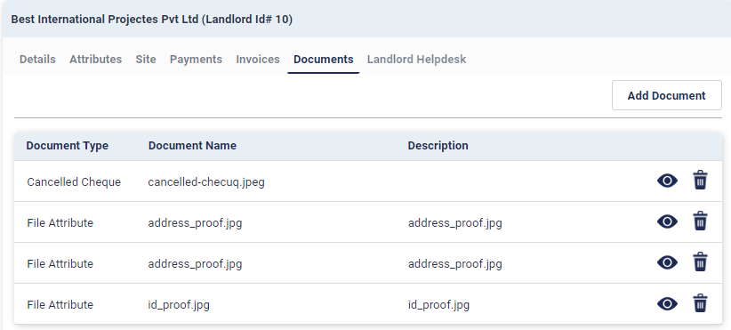

Figure 9 - Landlord Documents

* To add documents, click on  button.
* This will open the add document dialog



Figure 100 - Add Document Dialog

* Select “**Document Type**” from the drop down menu. The options are –
  + *Identification –* For human identification documents like ID card scanned copy or any Govt. issued ID.
  + *Address –* Proof of address kind of documents
  + *Image –* Images of the entity or of things related to the entity
  + *Agreements –* Agreements type of documents. Lease or Rent or Service agreements.
  + *Others –* Any other document category
* Enter a short description about the document.
* Click on the browse files to open the File dialog to choose the file from local system or drag and drop the file in the designated area.
* Click on the save button to upload the documents

### Landlord Helpdesk

Trouble Tickets can be raised to resolve issues or problems faced by the landlord. It is called reporting an incident. The application allows to raise and view and track incidents for landlords.

* To view and manage the incidents click on “**Landlord Helpdesk**” tab
* It shows the list of open or closed tickets or incidents raised against this landlord
* Following fields of the incident are shown in the list view –
  + **Docket#** - Identifier for the incident or ticket.
  + **Incident Name** – Name or type of the incident
  + **Status** – Status of the incident. Open or Closed

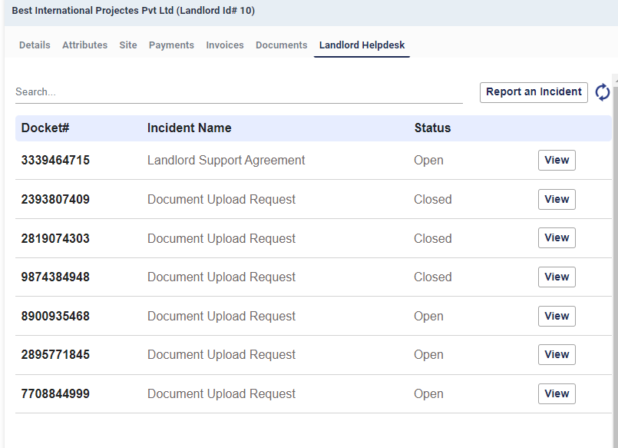

Figure 1 - Landlord Helpdesk or Incidents

* To filter the incident list –
  + Enter any text in the search bar. System will match the entered text with all the fields (Docket#, Name, Status) of the vendor list and filtered out the ones not matching.
* To refresh the incident list user may click on the  icon
* To view details of a ticket click on  button beside that ticket or incident.
* It will open the ticket / incident details dialog

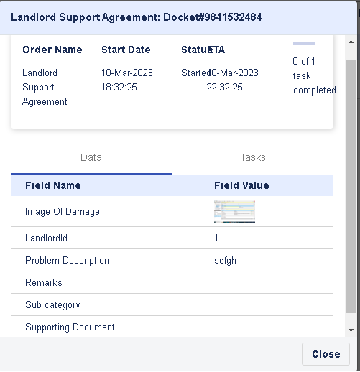

Figure 2 - Ticket Details Dialog

* It shows the following information –
  + Order Name – Name of the Incident
  + Start Date – Date on which the ticket was raised
  + Status – State of the ticket. Either Open or Finished
  + ETA – Expected completion time.
  + Progress bar – Shows number of tasks completed out of total number of tasks in the ticket
  + In the lower section it shows the data of the instance which were supplied during ticket creation or task execution. The data fields are dynamic and change from ticket type to ticket type as per template configuration
  + It also shows the task details of the ticket with following details –
    - Task Name
    - Task Type – Either Manual or Automatic
    - Task State
      * To Start – Task is assigned but the engineer or technician or user has not accepted it yet
      * Started – Task is accepted by the engineer or technician or user
      * Finished – Task is closed by the engineer or technician or user
    - Assigned To - The engineer or technician or user, the task is assigned to.

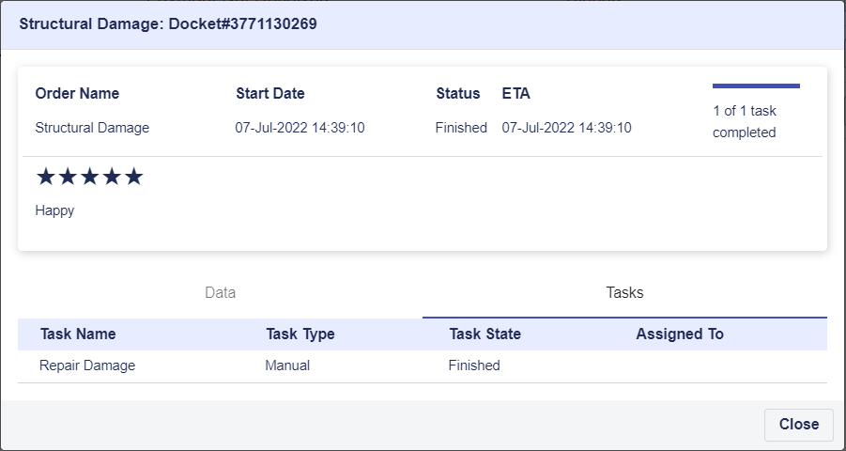

Figure 3 - View of Tasks in a ticket

Note: *This view of the ticket is read only, as in it can not be modified by the user. As and when the tasks are worked upon by the engineer or technician or user the view of the ticket gets changed accordingly*

*.*

* There is an option to provide rating and feedback on the closed tickets.
  + Click on the button.
  + This will open the Rating & Feedback window.



Figure 4 - Ticket Rating & Review Dialog

* + Click on the stars to provide rating.
  + Enter feedback
  + Click on  button to save the rating and review.
  + This will show the rating and feedback on ticket details page.

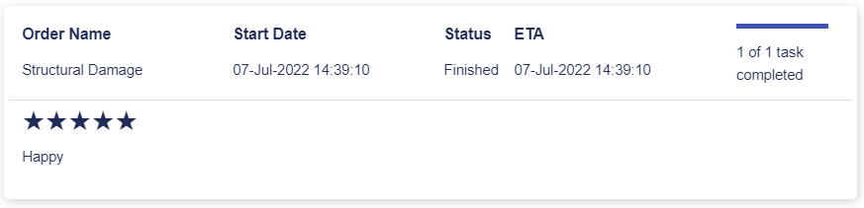

Figure 5 - Ticket Rating & Review

Note: *Rating & review can be provided only on closed ticket and only once. If rating and review is already given for a closed ticket it can not be given again.*

* To report a new Incident or raise a new ticket –
  + Click on the button.
  + This will open the Report Incident dialog
  + Select the Incident Type to raise, from the drop down.
  + The list can be filtered by typing the search text in the search bar
  + Based on the selected incident type, launch parameters are loaded dynamically.
  + Enter values in the launch parameters as appropriate.
  + Some of the launch parameters may have value already populated and disabled. Ignore them.
  + Click on the save button to create the incident.

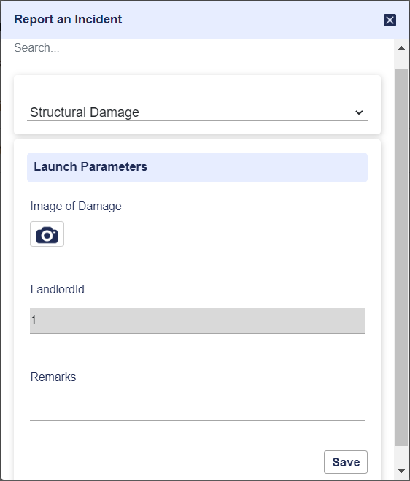

Figure 6 - Report an Incident Dialog

* + Once the incident is successfully created a message appears with the docket number.



Figure 55 - Incident Creation Message

* + The docket also appears in the ticket list with Open status
  + System allows raising same types of ticket multiple times for the same asset

# User Management

To go to User Management view click on the on the left menu bar.

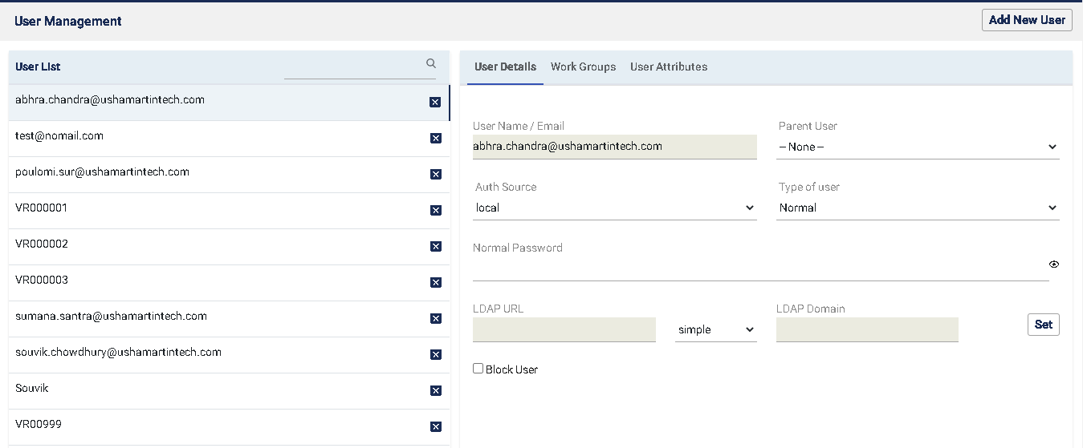

There are two sections of User Management.

* On the left side there is “User List”.
* On the right side there are three tabs where user can see User Details, Work Groups, User Attributes for each users.

## Add New User

* Clicking the “Add new User” button an “Add User” screen will open up.

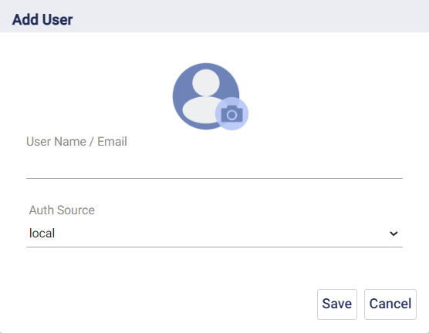

* Clicking the icon user can upload a profile picture or display picture for that new user.
* Then user has to input User Name/ Email.
* Select local for Auth Source.
* Clicking the  button the new user will be added. Or user can revert back clicking the  button.
* Once the user is successfully created a message is shown to that effect.

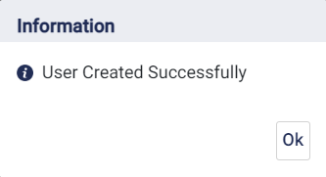

* Also an email to the user will be sent with the auto generated password. Also the newly added user will be shown in the left side user list.

## User List

* Here user can see the list of other users’ User Names or Email Addresses. User can filter users by typing User name/ email beside the  icon.
* Clicking the  icon user can delete any of the listed users.

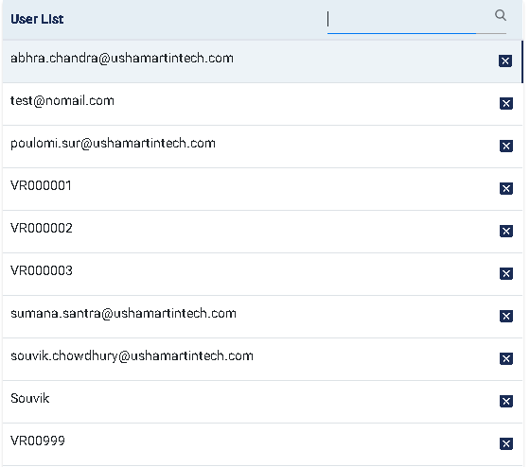

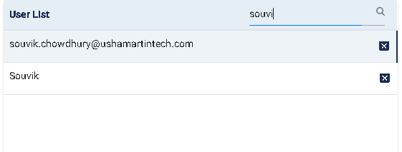

## User Details

In the User Details section the following details for each user is shown-

* User Name/Email- It’s the user name for that particular user.
* Parent User- User can select it’s value from the drop down.
* Auth Source- User can select it’s value from drop down.
* Type of User- User can select it’s value from drop down.
* User can change password by providing the new password in the Normal Password field and pressing “Tab” button. Only the Admin user can change other users’ passwords. By clicking the icon the password can be made visible or invisible.

Once the password is successfully changed a pop up message is shown.

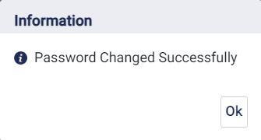

* LDAP URL(not applicable)
* LDAP Domain(not applicable)
* User can block the user by checking the box. A blocked user can not login to the system.

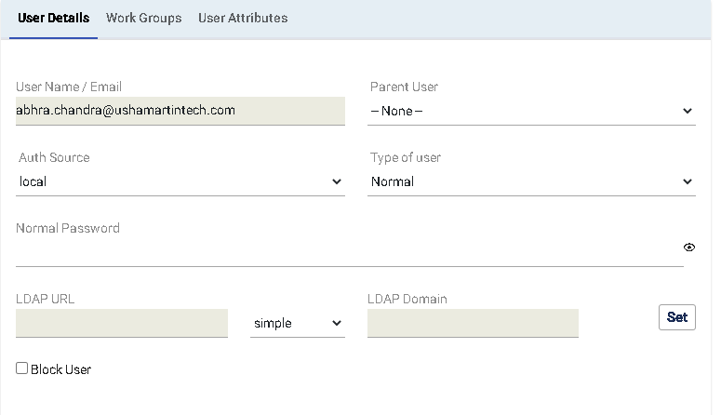

## Work Groups

Here user can add work groups to a particular user.

* User can select work groups from the drop down .
* By checking the box user can make the work group inheritable
* By clicking the button user can add the work group to that user.
* In the lower section user can see the Work Group Names, and their types for the particular user.
* By clicking the icon user can delete any workgroup for the particular user.

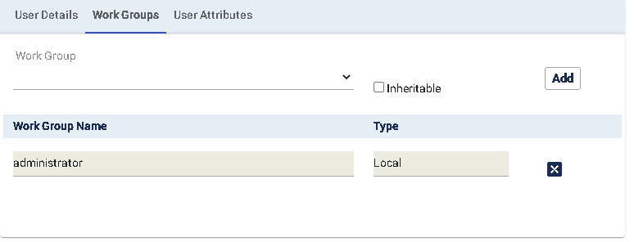

## 9.5 User Attributes

- Here user can add “Attribute Name” and “Value” for that Attribute Name for that a particular user.

- In the lower section user can see all the Attributes list for a particular user.

- clicking the button user can add a new attribute to a particular user.

- clicking the button user can delete any attribute of a particular user.

### User Skill

“Skill” is a special attribute of the user which is used by the System to automatically allocate workflow tasks to a user. Some workflow tasks as mentioned below have skill associated with them. When those tasks are created the Workflow engine looks for users having the matching skill and assigns the tasks to those users.

Following is a mapping between workflow tasks and skills required to perform them.

* Workflow Name – **First Document Approval**
* Task & Skills mapping
  + Task “Verification and Approval by Acquisition Senior Team” requires skill “Acquisition Team Agreement Approver”
  + Task “Verification and Approval by Legal Team” requires skill “Legal Team Agreement Approver”
  + Task “Verification and Approval by EMG Team” requires skill “EMG Team Agreement Approver”
  + Task “Verification and Approval by Finance Team” requires skill “Finance Team Agreement Approver”
* Workflow Name – Landlord Support Financial Issues or Queries or Landlord Support Operations Issues or Queries or Landlord Support Agreement or Landlord Support Project Vidyut or Landlord Support Others
* Task & Skills mapping
  + Landlord Support Activity by EMG Team -> Landlord Support
* Workflow Name – Document Upload Request
* Task & Skills mapping
  + Landlord Info Change Approval -> Landlord Support

For example to perform the task of “Verification and Approval by Legal Team” during First Document Approval, the user needs to have the skill named “Legal Team Agreement Approver”. One user may have as many skills as required. In case of multiple skills, they need to be mentioned comma separated.

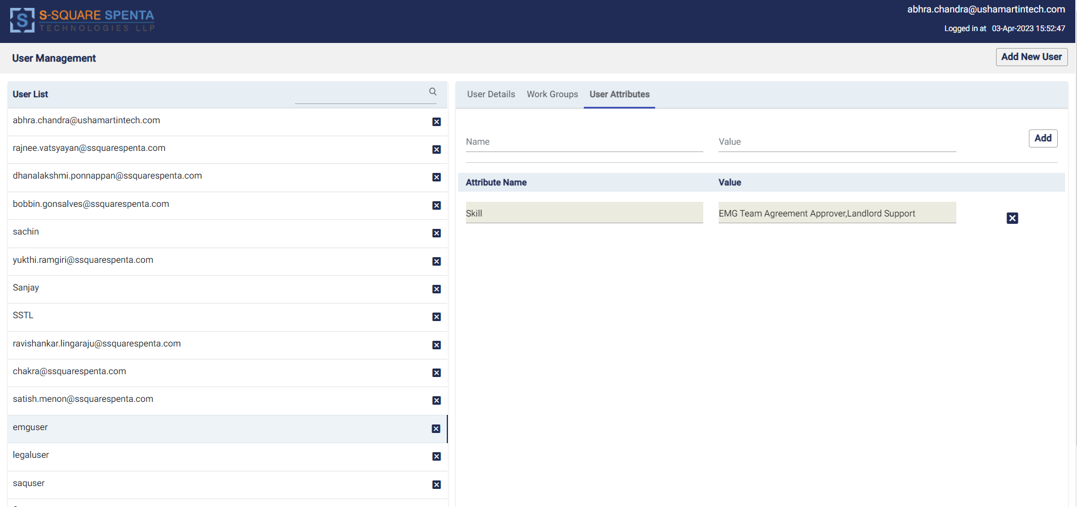

Figure 56 - User Skills

# Galaxy

To view the sub meter reading records received from Galaxy, click on the on the left side bar. This will open the Galaxy view GUI. The readings will be displayed in tabular view.

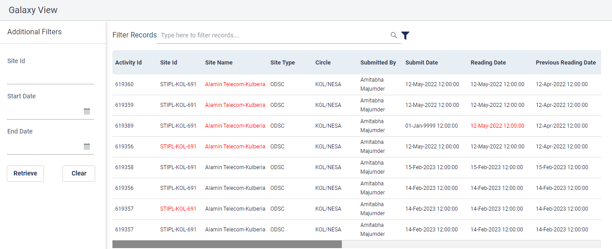

Figure 57 - Galaxy Meter Reading View

* By clicking the  user can open up a new window “Additional Filters”. Here user can put values in the respective fields Site Id, Start Date, End Date.

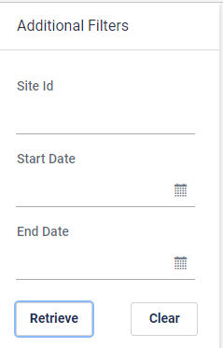

Figure 58 - Galaxy Record Filter

* By clicking the  button user can retrieve information.
* Here upon giving the Start Date and End Date values user will get the rows where Submit Date lies between the Start Date and End Date.
* If user does not put any values in the filer criteria then upon clicking the “Retrieve” button the user will get all the information.
* By writing any relevant value like date or site name etc. on the search bar beside the  button user can filter data for further.
* At the very last of every row there is a checkbox.  Only the records that have the status “To be processed” can be selected by checking the box. Any authorized user can “Approve”, “Reject” or “Reset” the record by clicking the respective buttons ,,at the bottom of the screen.
* If user rejects a particular data the reason can be mentioned at the “Reject Reason” column of the table.
* By clicking the button at the “Current Submeter Picture” column a screen will pop up with the picture of the current sub-meter
* By clicking the  button the filter section will be refreshed.

# Invoice Management

To go to the “Invoice Management”, view click on the left side bar.

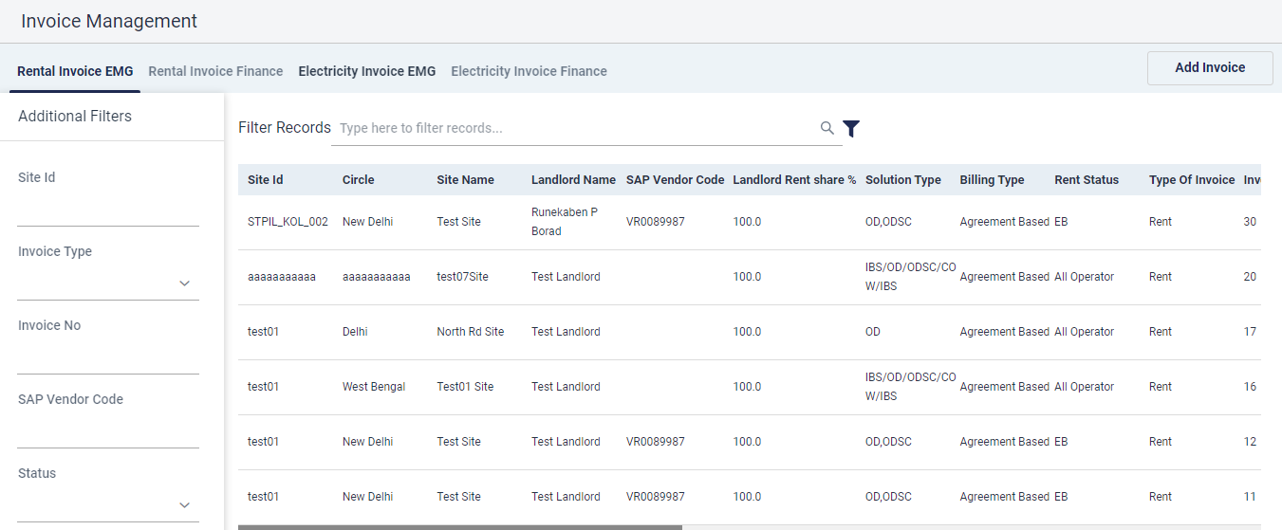

Figure 59 - Invoice Maagement

There are four tabs in the “Invoice Management” view naming “Rental Invoice EMG”, “Rental Invoice Finance”, “Electricity Invoice EMG”, “Electricity Invoice Finance”. For “Rental Invoice EMG” and “Electricity Invoice EMG” tabs

* By clicking the  user can open up a new window “Additional Filters”. Here user can put values in the respective fields Site Id, Invoice Type, Invoice No, SAP Vendor Code, Status, Start Date, End Date.
* By clicking the  button user can retrieve information.
* If user does not put any values in the filer criteria then upon clicking the “Retrieve” button the user will get all the information.
* By clicking the  button user can clear the filer fields.
* By writing any relevant value like date or sitename etc on the search bar beside the  button user can filter data for further.
* For every row of the table user can see the invoice by clicking the  icon under the view column.
* User can select each or multiple rows by checking the checkbox icon  under the select column. And then further “Hold”, “Unhold”,“Approve” or “Reject” the data by clicking the respective buttons , , , .
* User can enter remarks under the remarks column for each record.
* Only the approved records from “Rental Invoice EMG” and “Electricity Invoice EMG” will be shown in “Rental Invoice Finance” and “Electricity Invoice Finance” tabs respectively.

For “Rental Invoice Finance” and “Electricity Invoice Finance” tabs user can “Approve”, “Reject” or “Save TDS” for any particular or multiple records by clicking the ,, buttons respectively.

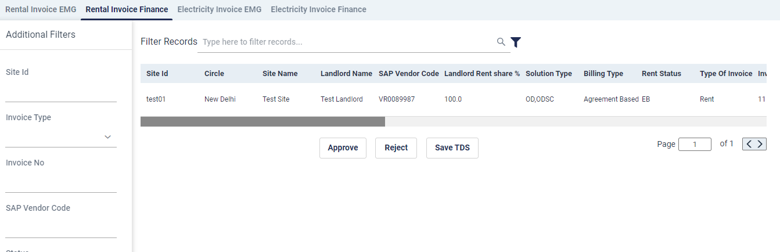

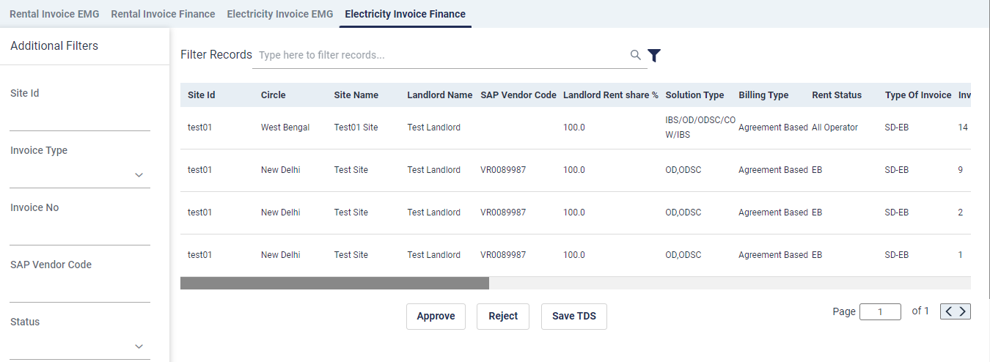

## Add Invoice

In the “Rental Invoice EMG” and “Electricity Invoice EMG” tabs user can add invoice by clicking the  button.

Clicking the button will pop up a new window

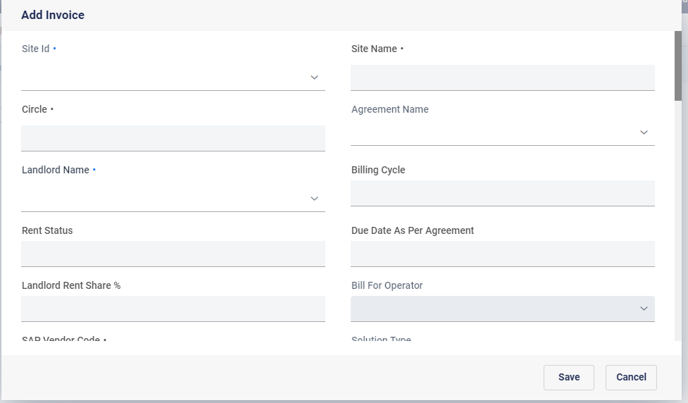

By selecting the Site Id from the drop down the dependent values will automatically be selected and the user has to manually input other details.

Clicking the  button will open up a new screen where user have to upload an Invoice document. User can browse from files or ‘drag and drop’ files and user have to provide some description regarding the document. After that clicking the  button will save the document.

After filling all the details and clicking the  button a new invoice will be added.

For electricity invoice additional data fields like meter readings, meter serial numbers, electricity charges etc. needs to be entered.

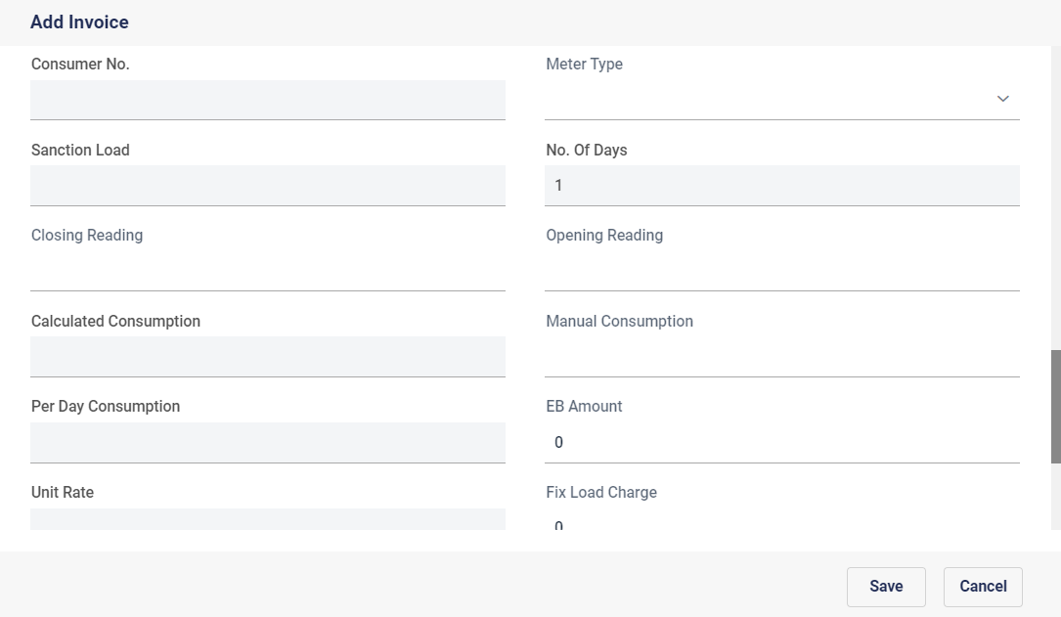

Figure 60 - Electricity Invoice Addition data fields

## Edit Invoice

Both Rental and Electricity Invoices can be edited by EMG team from “Rental Invoice EMG” and “Electricity Invoice EMG” tabs correspondingly. Invoices which are in status “To-Be Processed” or “Rejected by Finance” can be edited and resubmitted. Invoices approved by EMG or in Hold status can not be edited.

To edit an invoice, select the invoice and click on the icon.

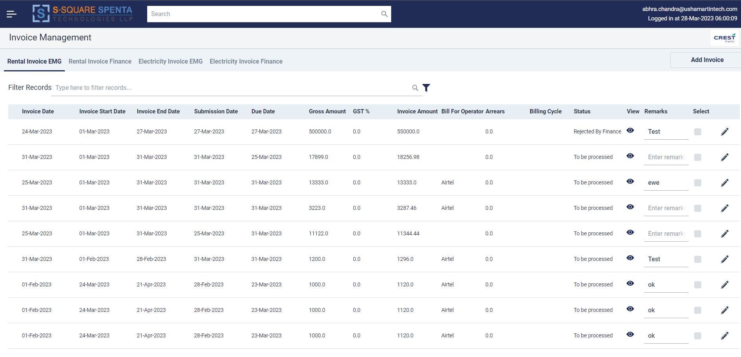

This will open the invoice edit dialog. Modify the details as required. Please note uploading a document is mandatory. Once done save the details.

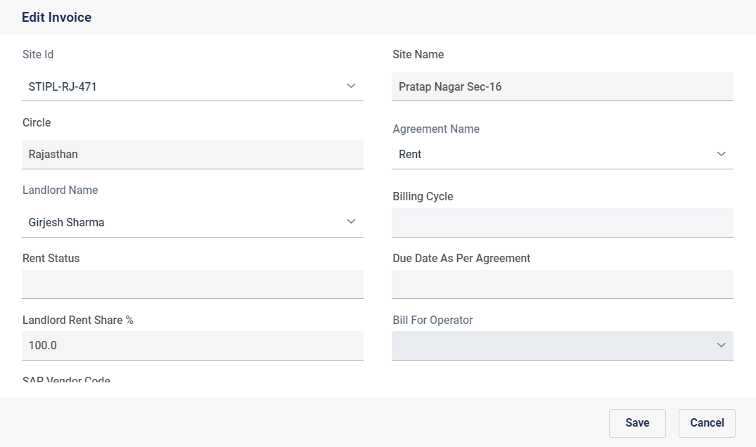

# Audit Trail View

To go to the “Audit Trail” view user have to click  in the side menu bar.

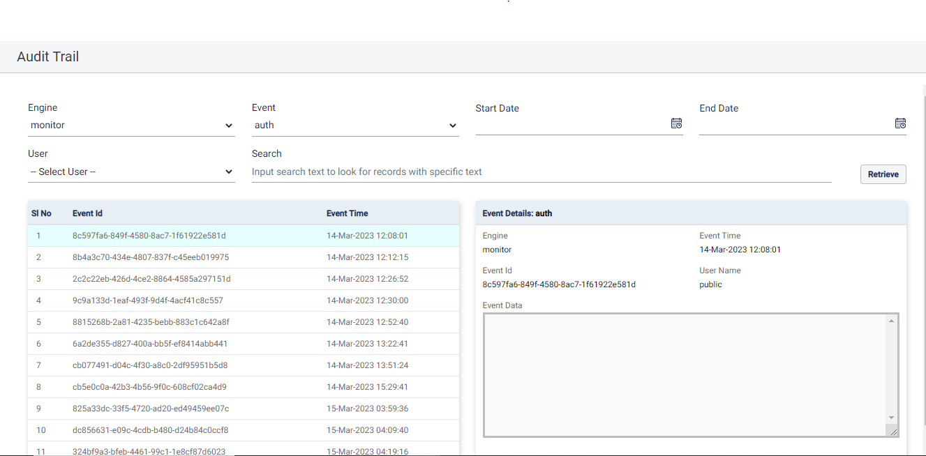User can select values for “Engines”, “Events” and “Users” from respective drop downs, “Start date” and “End Date” from clicking the  icon and input any relevant keyword at search field for further filtering. Selecting values for “Engines” and “Events” are necessary.

By clicking the button user can get data for that search in the below two sections.

In the left section there are three columns naming “Sl no”, “Event Id”, “Event Time”. User can select any data from the table by clicking it.

The right section Is called Event Details. Here user can see “Engine”, “Event Time”, ‘Event Id”, “User Name” and “Event Data’ for the selected data in the left section.

At the bottom user can alternate among page numbers  by clicking the arrow keys.

# Report View

To go to report view user has to click  in the side menu bar.

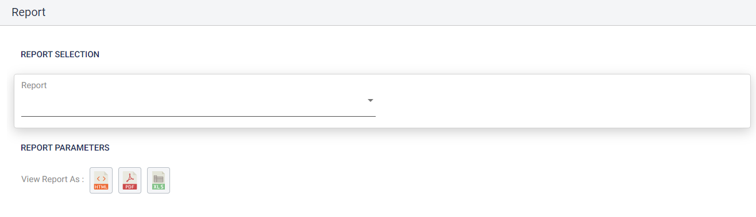

* Here users can select which report they want to download by selecting the Report type from the “Report Section” dropdown.
* By clicking the  button user can download the report in HTML format.
* By clicking the  button user can download the report in PDF format.
* By clicking the  button user can download the report in xls format.

# My Task

Clicking on the  menu item will take the user to his/her task work list. These are tasks assigned to the users by the workflow management system for different workflows and trouble tickets configured, i.e. First Document Approval, NFA or Landlord Support Tickets.

## Task Execution

From My Tasks GUI, users may view and execute the tasks in his/her bin.

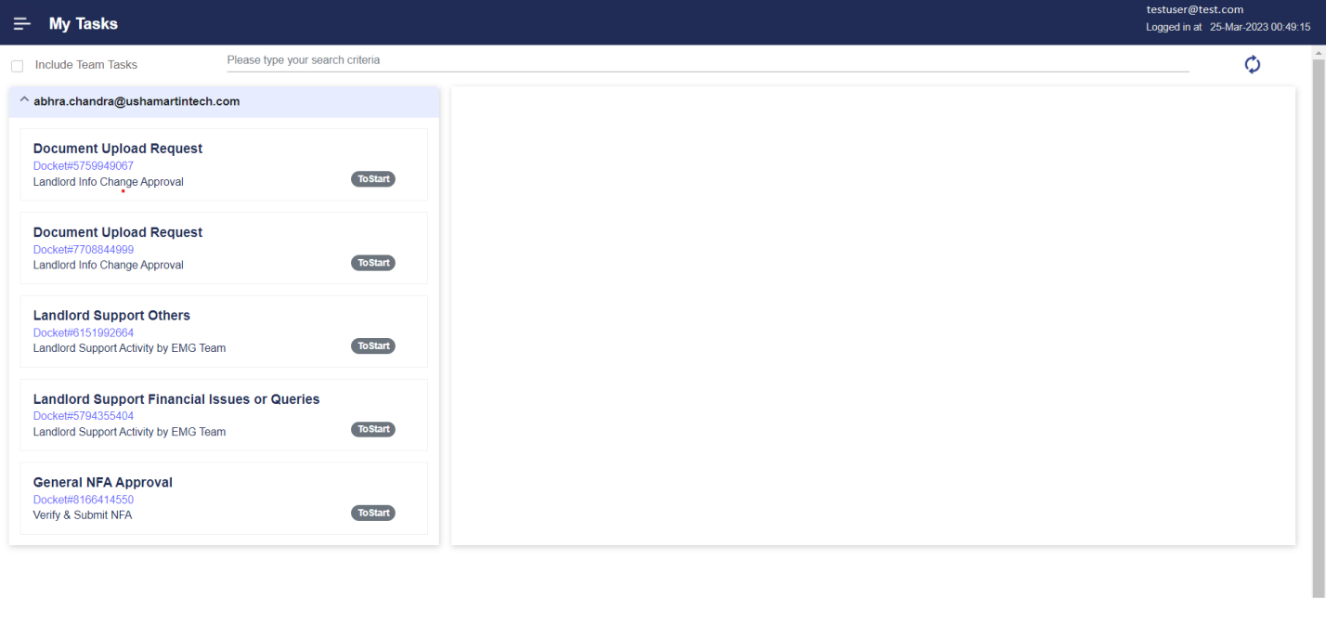

Figure 61 - My Tasks

User can do following:

* View list of tasks assigned to the user

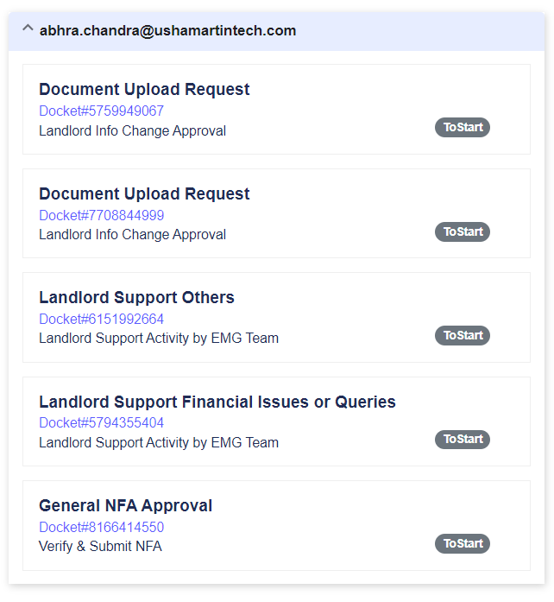

Figure 62 - Workflow Task List

* Can check the Include Team Tasks checkbox to view tasks of child users.

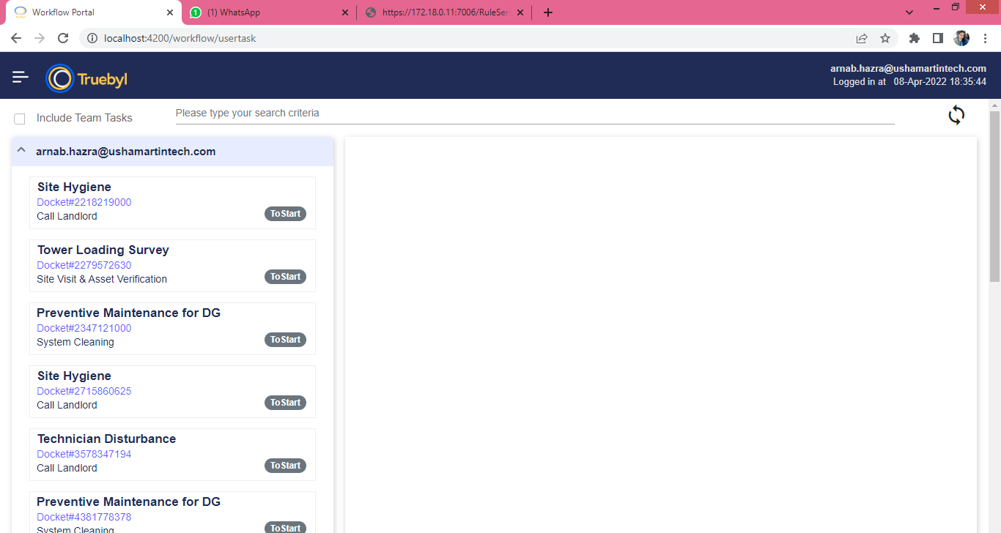

* Filter the list by Searching with task description or docket number



When a task is selected from the task list (on the left frame), the following details of the task can be viewed on the right side:

* **Basic Information**
* **Task Attributes**
* **Task Editable Fields**

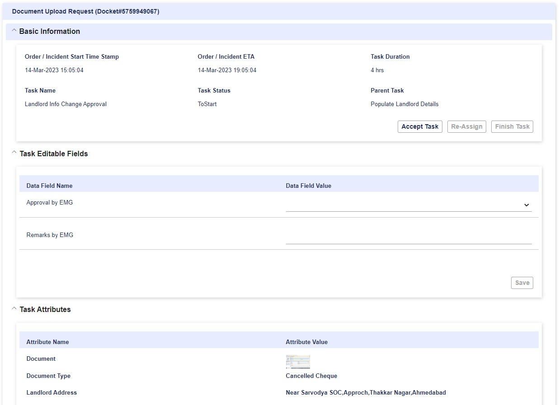

Figure 63 - Task Details

* **Basic Information:** This section will show the basic information for the selected task. User may select to accept task using  button and re-assign task using  button. Also user may mark the task as finished using Finish Task button.

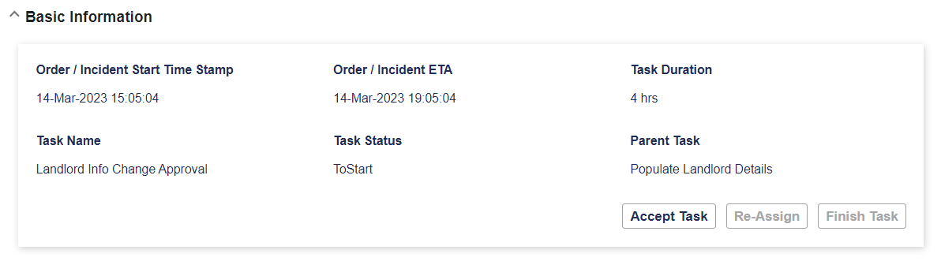

Figure 64 - Task Details Basic Information

* **Task Attributes:** This section shows the attributes for the selected task. It will list all the task attributes in key-value pair format.

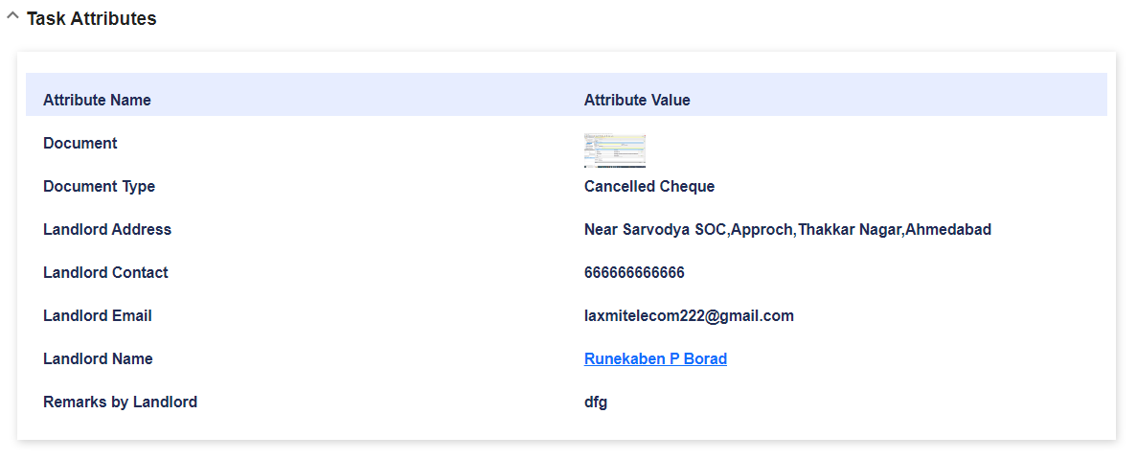

Figure 65 - Task attributes

* **Task Editable Fields:** This section shows all the editable fields for the selected task. The user may edit the data fields and save editable fields for the selected task.

Users can set values for task editable fields and press the  button. Once the data is saved successfully, the following dialog will appear:

**Task Operations and statuses:**

* If the task is not started yet, then task status will be: .
* When user will press button: , the following dialog will be shown. Pressing button: , task status will be changed to: .

* When user will press button: , the following dialog will open. There will be possibility to choose different user from drop-down list and press  to re-assign selected task to the chosen user. Button:  will cancel the re-assign operation and close the dialog.

* There will be possibility to finish the selected task using the following button:



When the selected task will be finished, the following dialog will appear:

## Tickets View

On clicking the 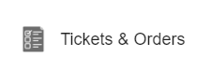 menu item user will be taken to the tickets view.

There will be two tabs:

* **Tickets**
* **Orders** (Not being currently used)

**Tickets:**

By default, the **Tickets** tab is selected and opened. This tab shows all the list of tickets/incidents raised by the user.

The following information is displayed for Tickets:

* **Docket#**
* **Incident Name**
* **Status**

User may view the details of the Tickets using  button.

When  button is pressed, the following dialog opens with two tabs: **Data** and **Tasks**.

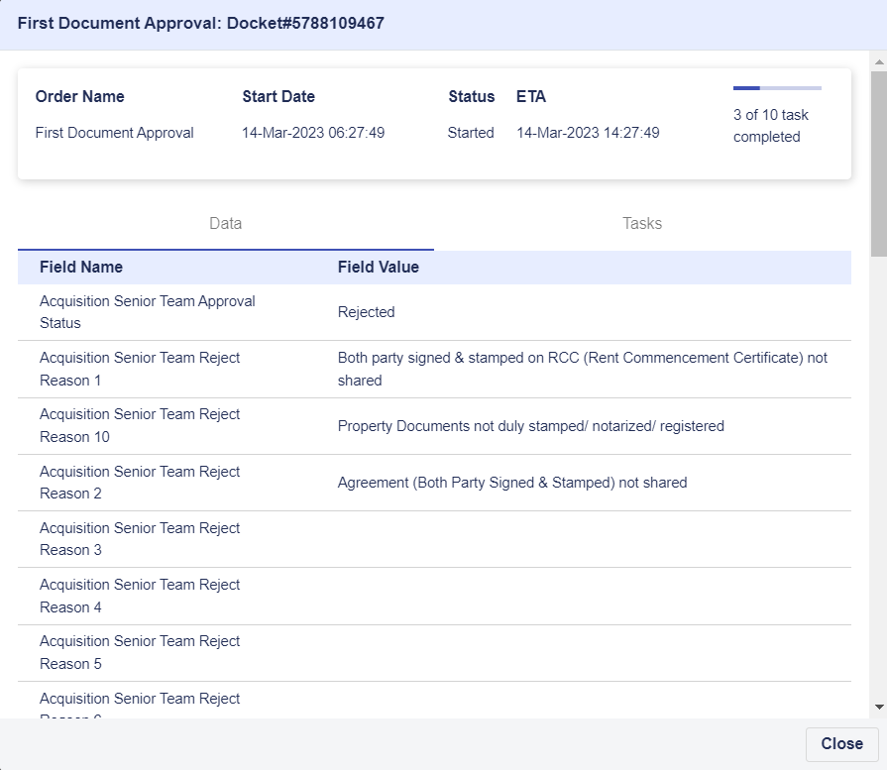

Figure 66 - Tickets data view

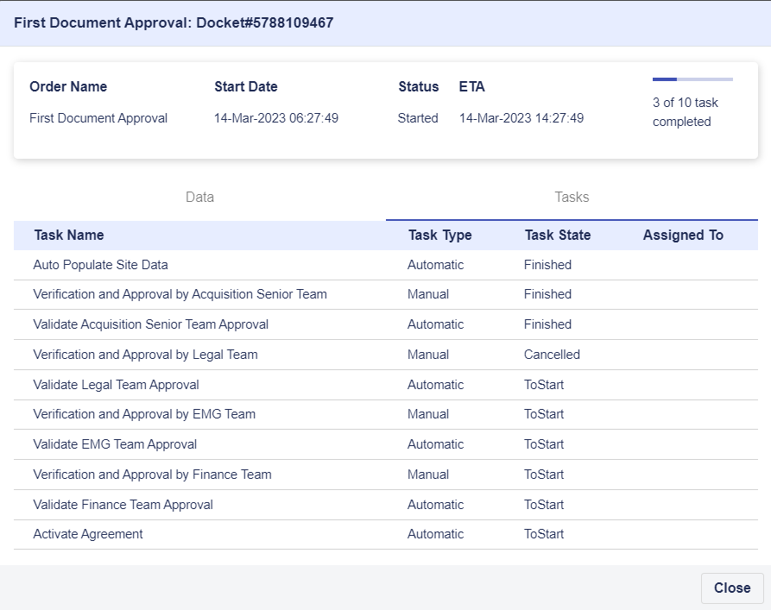

Figure 67 - Tickets Task View

When user will press button, the following dialog opens.

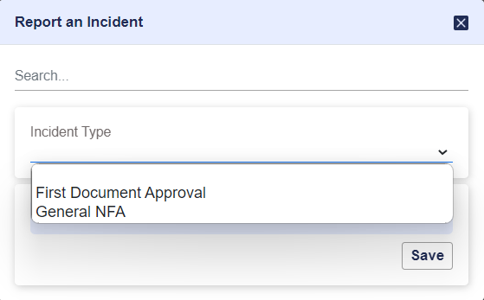

Figure 68 - Incident Report

Users may select the **Incident Type** from drop-down list. On selecting the incident type the relevant data fields for that incident type will be shown. Users can enter the parameter values and launch the workflow by clickingText, icon

When user submits the data, the ticket is generated and a docket number is created:

After new incident is created successfully, it will appear in the incident list below, after refreshing the view:

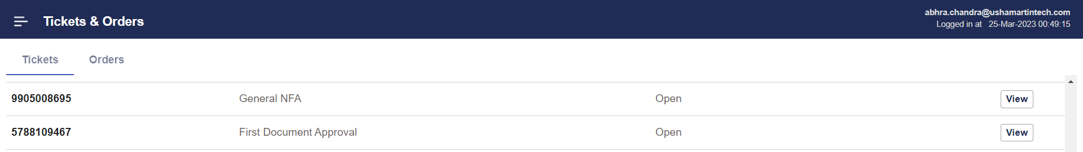

Figure 69 - List of tickets

# Change Password

To change password of an user, the user may go to the menu for 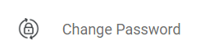. This will open the password change GUI.

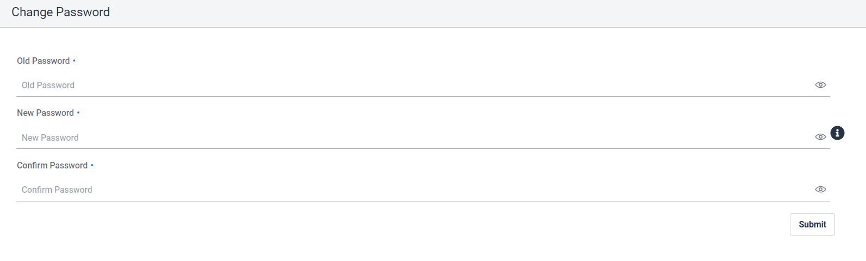

User has to enter the current password, the new password and retype the new password and submit. Once the password is successfully changed the user will receive a notification email. The user should logout and re-login with the new password.

Hovering the mouse over the  icon shows the password policy.

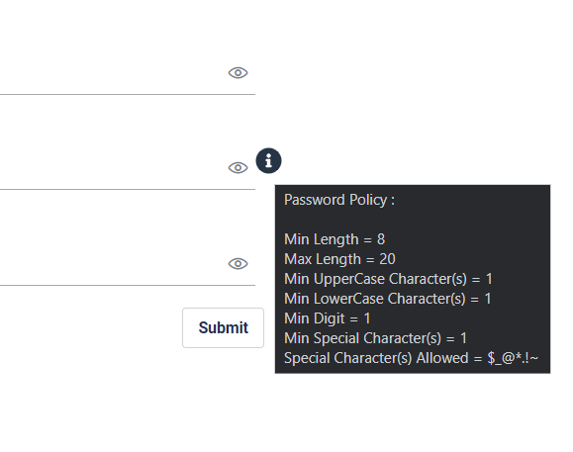

# NFA

Crest uses NFA process for hierarchical approval in case of deviation from standard operating procedures. For example - if rent needs to be paid to a realtor even before site MRFAI or for incorporating special conditions or clauses in rental agreement, approval process needs to be triggered and approval needs to be obtained.

Users may launch new NFA approval process from the My Tasks GUI.

## Launching NFA

* Go to Tickets & Order menu item of My Tasks menu.

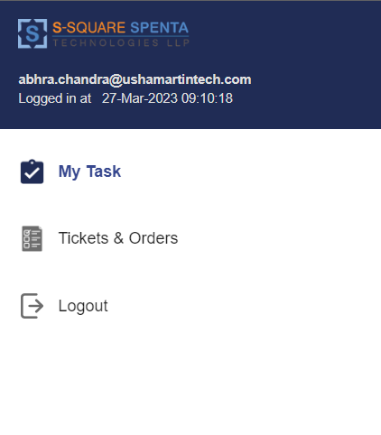

* This will open the tickets view of the user. All the tickets raised by the user in past can be viewed here.

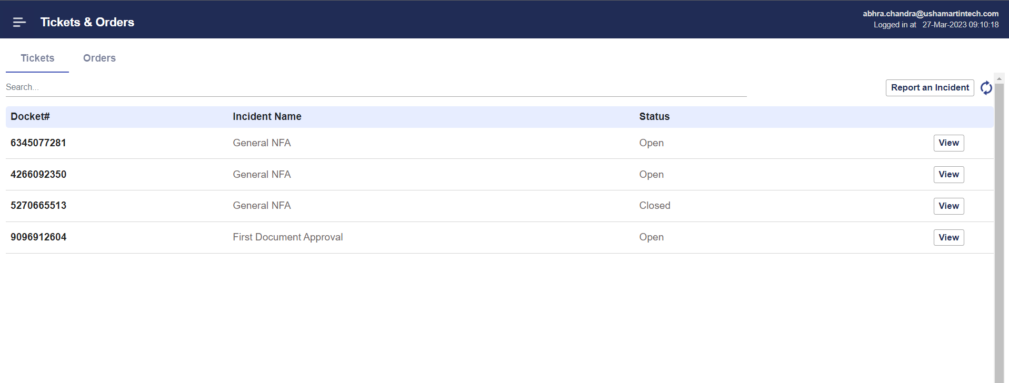

* Click on the “Report an Incident” button. This will open the incident launch screen. Select “General NFA”.



* Enter the NFA details

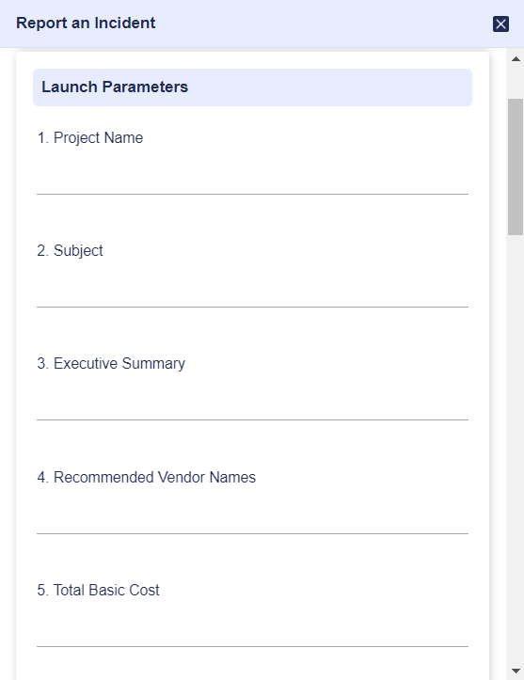

* Upload the required documents and select the approvers. At max 10 level of approvers can be selected. Click on Save button after all data is entered.

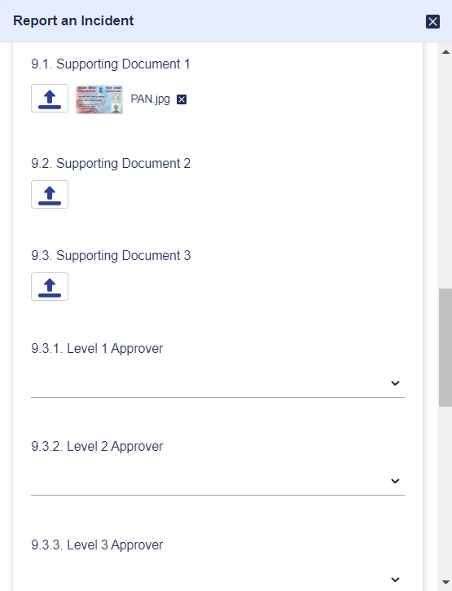

* A pop up message with the NFA docket number created will be shown

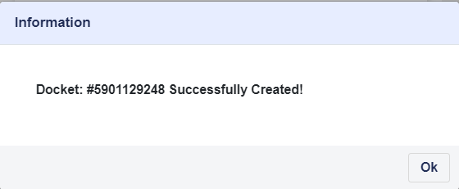

* Click on the refresh icon  on the Tickets view tab and the new NFA created should be visible in the list.

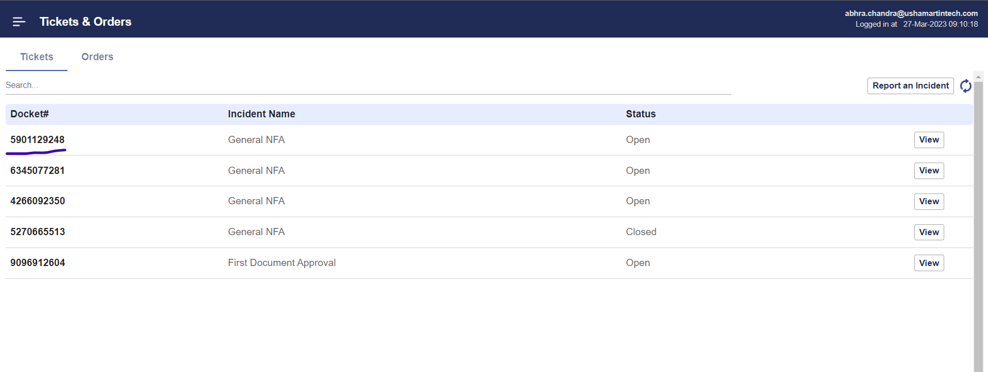

## Executing NFA

The first task of the NFA is assigned to the initiator, the person who launched the NFA. The first task is for verify and submit NFA. If any data entered during launching of the NFA needs to be modified or corrected, then it can be done in this step.

* Initiator will receive an email like below.
* 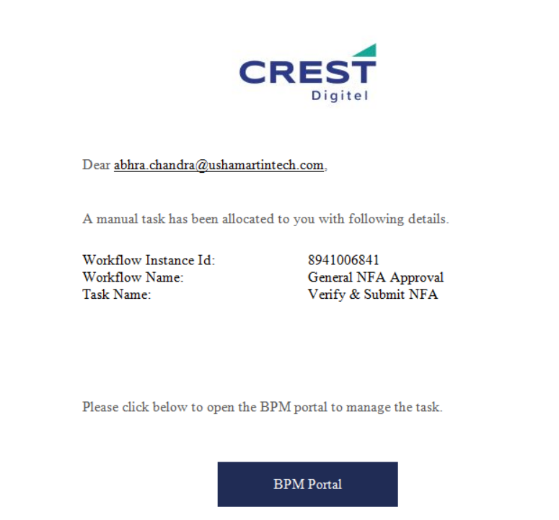
* To view and execute this task go to My Tasks menu.

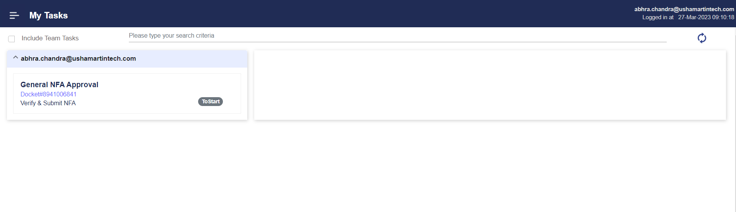

* The task should be visible in the left side.
* Selecting the task will show the details in the right side. User will be able to view and edit the NFA details and documents. Also the approver list can be changed.
* User needs to “Accept” the task first.
* Then change any data and “Save”.
* Finally user needs to “Finish” the task.
* Finishing the task will remove the task from the user’s bin.

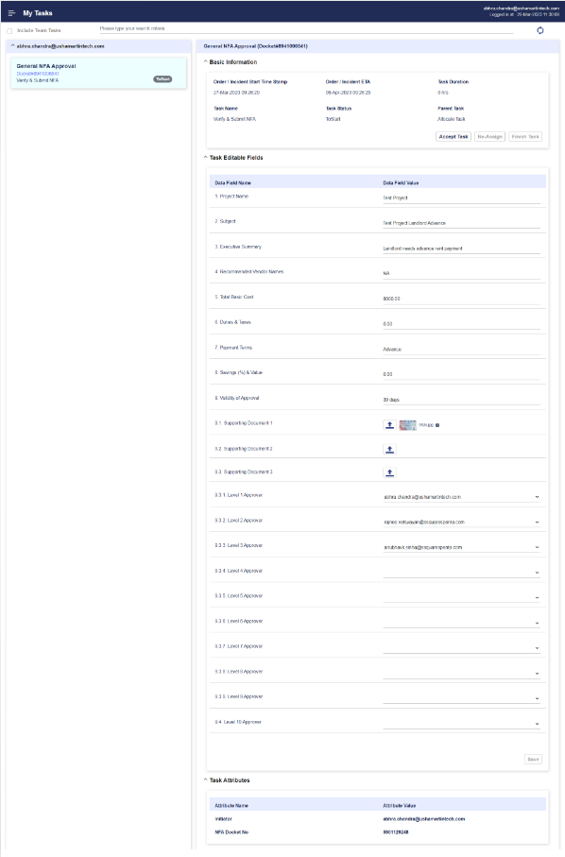

Figure 70 - NFA - Verify and Submit Task View

Once the initiator finishes this task, the approval tasks begin. The NFA is sent to the first approver. The task named “Verify & Approve NFA” is assigned to the level 1 approver. The level 1 approver receives a notification email. Once the level 1 approver opens my task, the task appears in his/her task list/bin.

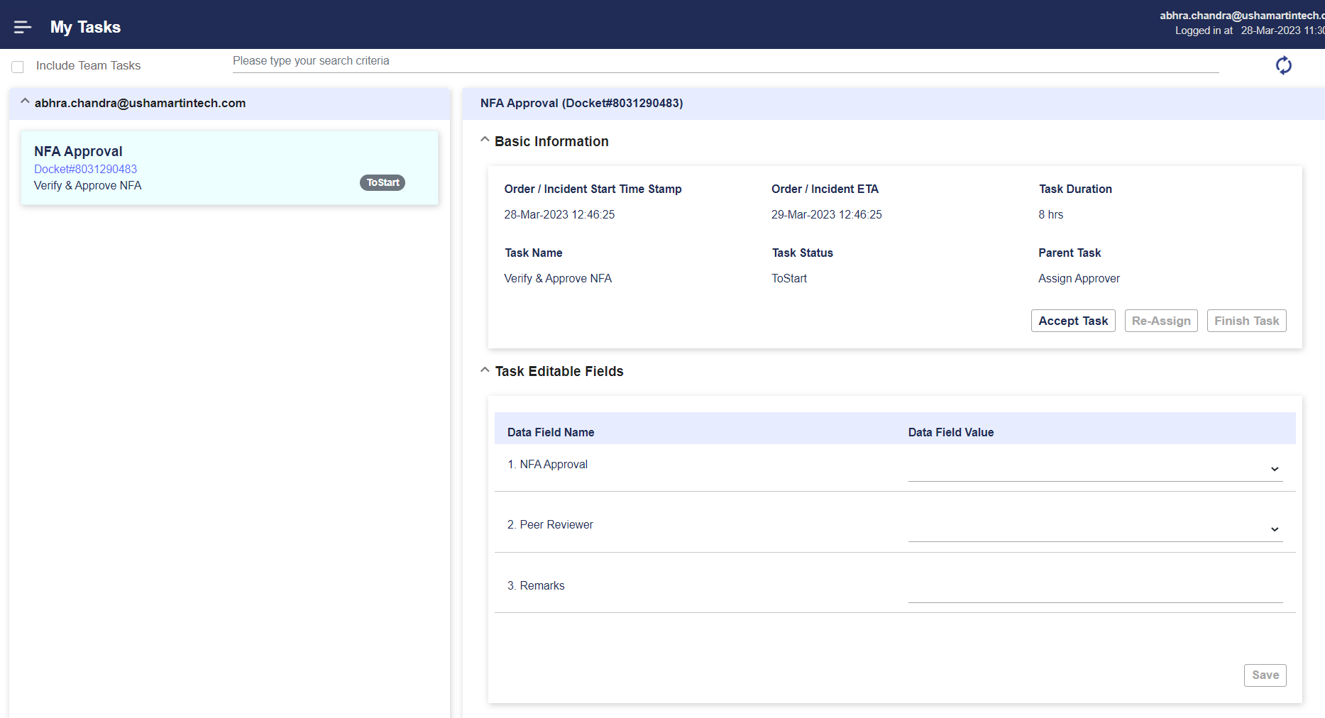

Figure 71 - NFA Approval Task

The approver needs to accept the task first. Then select the approval from the list and save the data. Finally the approver needs to finish the task.

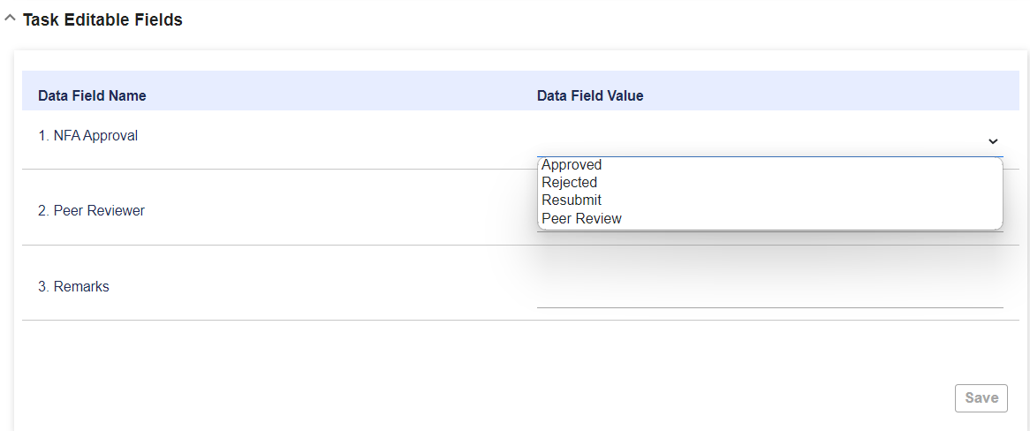

Figure 72 - NFA Approval - Available Options

In case it is “Approved” – The NFA moves to the next level of approver. If this is the last level, then the NFA is marked as Approved and reassigned to the initiator.

In case it is “Rejected” – The NFA is cancelled. An email is sent to the initiator informing the cancellation of the NFA with the rejection reason and approver who rejected.

In case it is “Resubmit” – The NFA is sent back to the initiator. A task is assigned to the initiator named “Verify and Submit NFA”. An email is sent to the initiator informing the task allocation.

In case it is “Peer Review” – The user needs to select the peer reviewer. The NFA is sent to the peer reviewer. A task is assigned to the peer reviewer selected named “Verify and Approve NFA (Peer)”. An email is sent to the peer reviewer informing the task allocation.

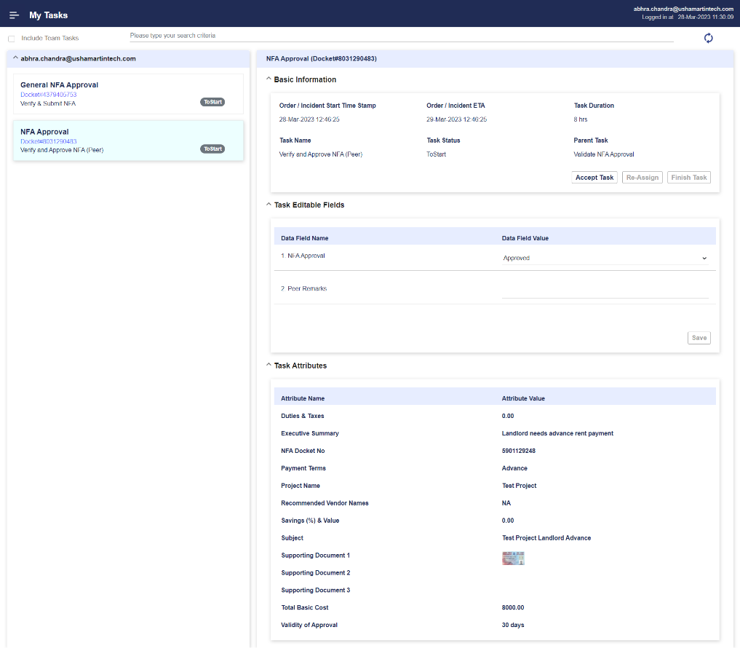

Figure 73 - Peer Review

The peer reviewer can approve or reject or ask for Resubmit. In case it is approved it is moved to the approver who asked for the peer review. A task named Final Verification & NFA Approval is assigned to the approver. The original approver may view the comments and approval provided by the peer reviewer.

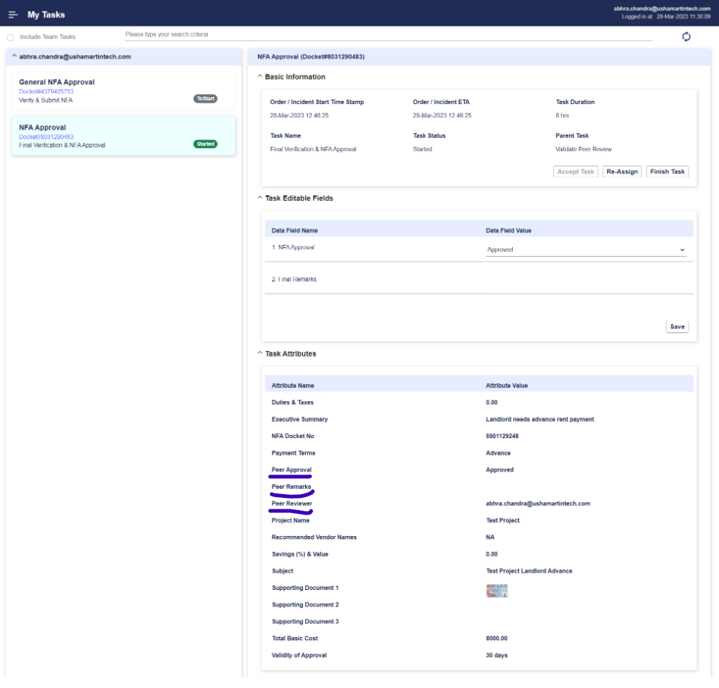

Figure 74 - Verification and Approval after Peer Review

If it is rejected, the NFA is cancelled. An email is sent to the initiator informing the cancellation of the NFA with the rejection reason and approver who rejected. If it is Resubmit - the NFA is sent back to the initiator. A task is assigned to the initiator named “Verify and Submit NFA”. An email is sent to the initiator informing the task allocation.

Once all the approver has approved the NFA is “Approved” and a final task is allocated to the Initiator. An email is also sent to the initiator. The initiator may accept the task and review the NFA status and finish the task.

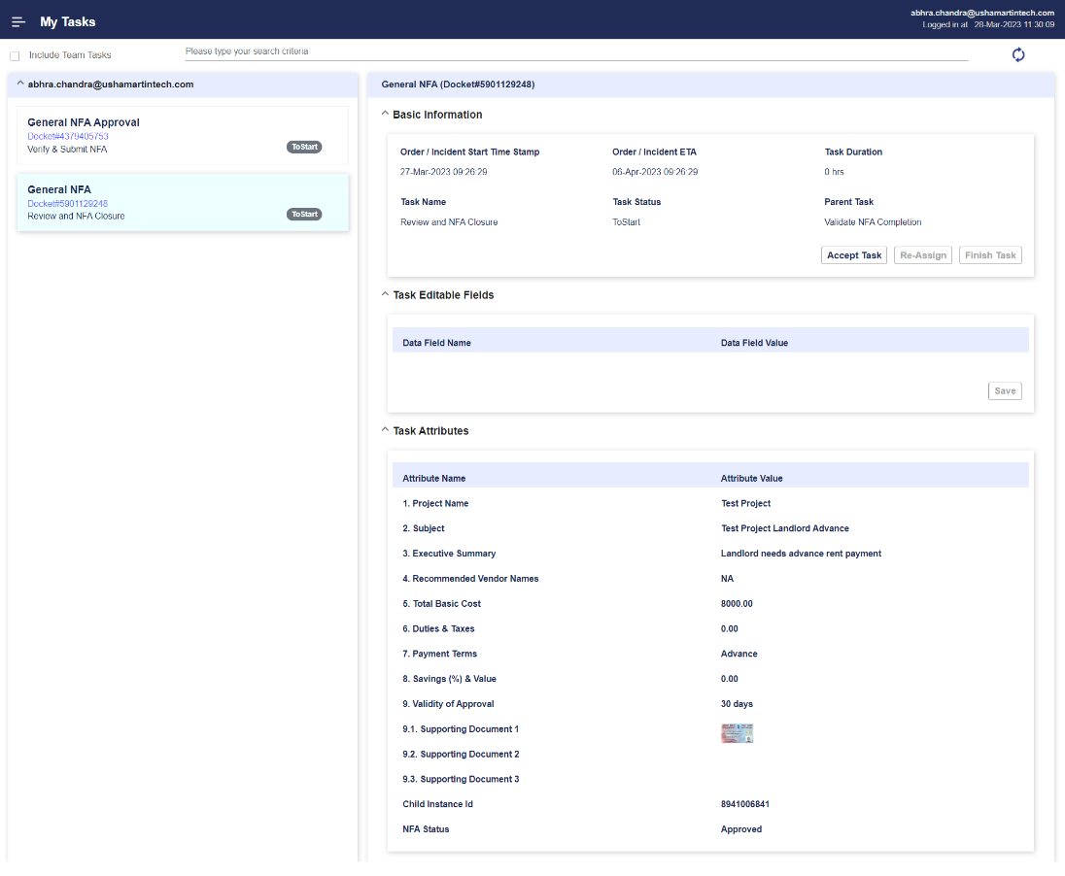

Figure 75 - NFA Approved.

Once the NFA is approved it can be checked from the Tickets tab. Details of the NFA can be viewed by clicking the View button.

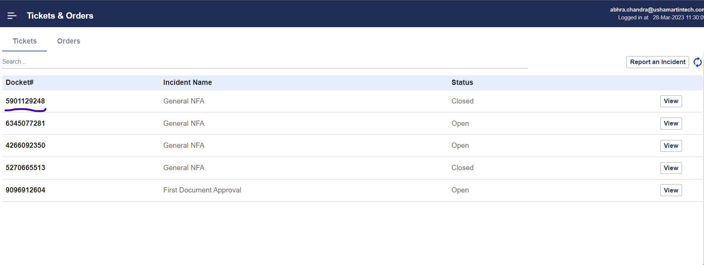

Figure 76 - NFA Approved and Closed